Letter of Transmittal

Mr. Dieter Zetsche

Mercedes – Benz Headquarters

Stuttgart, Germany

February 14th, 2019

Dear Mr. Dieter Zetsche,

I am addressing your reputable company, Daimler-Motoren-Gesellschaft (DMG) owning Mercedes-Benz, to propose the implementation of the designed safety systems for hearing impaired drivers. The achievable design will include features that will alert the driver of emergency situations that occur within the vicinity of a driver’s location. The aim is to minimize the margin of risk between a healthy driver and one that does not possess their auditory ability.

Kind Regards,

Youssef Zaghloul

Yousuf Abdulmalek

Mohammed Al-Fakhri

Lobna El-Bakary

Menatallah Ellag



**We approve that the authors contributed equally to the writing of this report, and that permission is given to Dr Amin Komeili to deliver this report should we fail to deliver it to the target organization**

**SATURDAY, APRIL 6TH, 2019**

**UNIVERSITY OF GUELPH, GUELPH, ON**

***IMPLEMENTATION OF SAFETY SYSTEMS IN MODERN CARS FOR INDIVIDUALS POSSESSING HEARING IMPAIRMENTS***

**AUTHORS:**

**YOUSUF ABDULMALEK (SMP #: 063545)**

**MOHAMMED AL FAKHRI (SMP #: 063332)**

**LOBNA EL-BAKARY (SMP #: 059064)**

**MENATALLA ELLAG (SMP #: 063502)**

**YOUSSEF ZAGHLOUL (SMP #: 058988)**

**Presented to:**

***Daimler-Motoren-Gesellschaft (DMG) – MERCEDES-BENZ***

# Executive Summary

Driving, often thought of as a birth right, is a skill that improves over time and requires the use of human senses such as touch, sight and sound. The loss of either of these sense compromises the safety of the driver and the surrounding vehicles and therefore creating a dangerous environment. Expecting a driver to be at their full potential while one of their senses are compromised is unrealistic and therefore the main aim of this paper is to discuss the potential of designing a system that can assist the driver.

Drivers rely heavily on their auditory sense to keep aware of their environment. Studies have shown that the brain receives auditory information about their surrounding before they are able to see it with their eyes. A simple example of that is when an emergency vehicle is approaching, the blaring sirens could be heard from a vicinity, but it could take a few seconds for the drivers to pin point where the vehicle is. This simple example demonstrates that drivers with hearing impairments could be a danger to themselves and to society.

*Hear House’s* main goal is to help individuals with hearing impairments lead a regular life without feeling like they put themselves and others at risk. Another aim for Hear House is to incorporate additional safety features for vehicles targeting drivers who are heavily distracted on road by playing loud music or any other distractions that could occur.

Different solutions are laid out to show the process of developing a final solution for Hear House. Hear House’s system is composed of a phone application that acts as an alert system for the driver. Alerts will be displayed on the phone screen and detected through microphone sensors that will be placed inside the rear tail lights of the vehicle. These sensors can withstand very high and low temperatures proving its durability and extending its fatigue life. An additional touch sensory vibration unit will be installed in the steering wheel to act as an extra safety feature for the driver. Required tools and components are also listed to further specify the technicality of our design. Our design is developed and implemented by following certain constraints and criteria that are outlined in this report. These include the different codes and regulations that need to be followed to develop this design.

Potential risks and uncertainties are evaluated through sensitivity analysis of our design. These risks are evaluated through varying design parameters that would have a direct or indirect effect on other design components such as cost and any potential risks associated with Hear House that could be potentially foreseen in the future.

Finally, the potential environmental, social, and economic impacts are discussed in order to evaluate the different technical aspects of our design. Some of these impacts include the process of recycling the microphone sensors. The cost of this design is evaluated through gathering maintenance costs, labor costs and capital needed for the design. The capital cost for this design came up to $418,406 CAD with a payback period of 3.98 years.

Table of Contents

Executive Summary 1

1.0 Introduction 1

1.1 Problem Description 1

1.2 Background Information and Literature Review 3

1.2.1 Medical Background about Hearing-Impaired Drivers 3

1.2.2 Current Solutions 6

1.2.3 Social, Economic, and Environmental Impacts 7

1.3 Scope of Project 8

1.4 Constraints and Criteria 8

2.0 Design Solution 11

2.1 Design Process 11

2.2 Prospective Design Solutions 12

2.2.1 Design Solution One 12

2.2.2 Design Solution Two 13

2.2.3 Design Solution Three 14

2.3 Detailed Final Design 15

2.3.1 Mechanisms, Components, and Tools Required for Selected Design 15

2.3.3 Microphone 18

2.3.4 Analog-to-Digital Conversion Processor 20

2.3.5 Filtration Processes 20

2.3.6 Digital Signals Processing 22

2.3.7 System Power Supply 23

2.3.8 Bluetooth Module 24

2.3.9 Steering Wheel Haptic Alert 24

2.4 Cost of Design Implementation 25

3.0 Design Defense 26

3.1 Primary and Secondary Functions 26

3.2 Safety and Regulations Aspects 27

3.3 Economic Impacts 28

3.4 Environmental Impacts 28

4.0 Risks and Uncertainties 29

5.0 Conclusions and Recommendations 30

References 32

Appendices 37

Appendix A – Response to feedback 37

Appendix B – Decision Matrices and Selection Processes 39

Appendix C – Technical Calculations and Models to Support Design 45

Appendix D – Project Management: Project Timeline Breakdown 46

Appendix E – Cost Analysis 50

Appendix F – Sensitivity Analysis 54

Appendix G – Survey Results and Significance to Design Solution 56

# 1.0 Introduction

## 1.1 Problem Description

In our current world, deep inside a sea of technological advancements, we still meet individuals with special needs suffering from various disabilities. This strips away their freedom to live their everyday life in ease, efficiency, and experience low risk to any dangers that their disability may expose them to. An example of these individuals that yet do not have an effective solution on their hands are individuals suffering from hearing loss. The Canadian Hearing Society estimates that there are nearly 1 in every 4 Canadians experiencing some degree of hearing loss.1 As of 2006, there were 530,210 individuals in Ontario that identify as either deaf or hard of hearing.1 The society indicates that aging is the primary cause to the hearing loss, where approximately 46% of people between the ages 45 to 87 experience some form of hearing impairment.1 Furthermore, from the 46% that experience hearing loss, only 1 of 6 utilize hearing aids.2 Thus, the *Hear House* team will commit to finding solutions to the alarming system that suits an individual with auditory impairments that does not utilize a hearing aid. The main aim of the team is to highlight the conflicts that individuals suffering from any form of auditory impairments. Thus, the idea primarily stems from the need for hearing-impaired individuals to be able drive their car safely and be aware of their surroundings, meanwhile and experience a minimized amount of distractions that he/she might potentially engage in.

Once *Hear House* set the goal of improving the lives of those with hearing impairments, further research emphasized the social impacts it would have on individuals with hearing impairments. A study performed in 2016 examined the association between hearing difficulties and social isolation through assessing the difficulties present based on self-reported ability to engage in conversations.2 Individuals with hearing impairments tend to isolate themselves and withdraw from their surrounding in order to avoid the challenges of keeping up during a conversation.3 Furthermore, their isolation is also related to the embarrassment of using a hearing aid or over their hearing loss. Utilizing a system that can allow for safe driving would allow the socially isolated individuals to gain more confidence in their driving skills and potentially leading to changing other aspects of their isolation.

There are a few dangerous scenarios that can occur when a driver with hearing impairments is on the road. These scenarios are made possible because hearing is normally the first indicator of the driver’s surrounding. The driver’s inability to hear blaring sirens causes a cascade of delayed reactions in terms of pulling to the right-hand side, since the sirens are heard before the flashing lights are noticed. Another dangerous scenario involves a driver with hearing impairment backing out of a parking space in the lot. Even though the careful driver would check their surrounding as they are backing out a car can zoom down the lot aisle. The element of surprise can cause the driver to react in appropriately or not react fast enough. Lastly, lane changing can also present threatening situation due to the car’s blind spot. In such a situation, as person with normal hearing would react to the other car honking at them while those with hearing impairment would not hear or react to the honk.

Emergency vehicles, especially police cars, drive at high speeds while using the flashing lights and sirens to alert those in their vicinity to provide space for the vehicle to rapidly and efficiently pass through. Nonetheless, younger and older drivers both face challenges in responding to such circumstance. For instance, younger drivers tend to be already driving at significantly higher speeds than older individuals, and also tend to be very easily distracted. Thus, these factors elongate the response time of these drivers for up to 10 seconds. On the other hand, older drivers tend to face a challenge with their cognitive ability to take an instant decision to account for the emergency situation. As a result, their response time is increased for up to 15 seconds in order to effectively take a decision.

Unfortunately, nation-wide consolidated statistics could not be sourced specific to the Canadian emergency vehicle crashes.4 Nevertheless, various data sources prove the global need for a more effective utilization of the presence of a siren.4 Between 2004 and 2007 in Alberta, 1,169 emergency vehicle collisions have been reported, and of which 93% occurred in urban areas.4 The risk increased significantly at night time, and was lowest during off-peak period.4 The risk at night-time was referenced to the fact that the driver’s vision was impaired during darkness, and thus proved the necessity for the usage of an auditory stimulus.4 Additionally, many emergency vehicles do not utilize the siren at night time, and therefore the risk is induced by approximately two-fold. The highest number of collisions took place on rainy and foggy days, and were most related to the improper response to the emergency vehicle’s presence.4 Similar data is found in many countries, and the risk scale is increased as the size of the city increases.4 Thus, the necessity arose in order to design an alerting or stimulating system that will alert the driver in a minimal amount of time.4

A study that took place in 2010 concluded that older drivers with moderate to severe hearing impairment have a great difficulty driving in the presence of distractions.4 Furthermore, through conducting a simple anonymous survey (see Appendix), hearing impairment appears to decrease the capability of a driver to become alert and well-rounded with his/her environment. Such diminished capability may cause the driver to become unaware of the emergency sirens if they were present and most importantly being able to become alert to any dangers in the vicinity in his/her car through other cars’ honks.

An investing stakeholder would greatly benefit from providing the team with all the needed machinery and supplies to build the system. The reason underlies the fact that the investor would occupy a new position in the automotive industry /market that is providing the consumers in need with this technology, and therefore attracting a demographic that isn’t covered by any other company. This as a result will provide the stakeholders with a degree of freedom to market the design product as a necessity for individuals in need of it, as well as strategically set the market price for the product.

## 1.2 Background Information and Literature Review

2

### 1.2.1 Medical Background about Hearing-Impaired Drivers

Driving distractions are classified into three major types the first being the visual distraction where the driver takes his/her eyes off the road, the manual where the driver loses control of the steering wheel such as taking his hands off of its grip, and cognitive distraction in which the driver takes off his attention from the task being performed.5 It has been scientifically proven that deaf drivers use their vision extensively and are able to detect objects in their peripheral sight at a quicker rate, as the visual sensory becomes their only channel where stimulus is received.5

Researchers discuss that if drivers take short glances away from the roadway, the risk of drivers missing important safety events around them will heighten, and that the inability for the driver to hear auditory alarms will also increase the degree of negative consequences. 6 Driving is heavily dependent on the driver’s visual perception, and in return this creates an immense amount of cognitive load on the driver’s brain. 6 The cognitive load is the brain’s ability to perform a wide spectrum of activities and handle various functions, which in turn allows the driver to direct their full attention and cognitive resources to one task at a time, and therefore, the more tasks wo be performed by a driver, the higher the amount of cognitive capacity is needed. 5,6 Since the larger the visual perception is, the more load is placed on the deaf driver’s cognitive ability, an impairment to the cognitive powers of the deaf drivers may eventually occur, leading the driver to detrimental loss in the ability to control the motor vehicle and become fully aware of his/her environment. Furthermore, interesting findings prove that the heightened cognitive load interrupts the cognitive processing of roadway and safety information and influences the driver’s reaction time by slowing it down. 5,6 The slower the reaction times of a deaf driver suffering from a cognitive load, the higher the potential is for lethal events to take place. Such slowed processing time won’t provide the driver with the time needed to signal the body to avoid an accident or to ensure the car stops with a good braking distance to safely bring the car to a stop. 5 Such delayed reaction time will result in degraded speed and headway control, as well as the decreased sensitivity of drivers to environmental cues to anticipate a time at which a brake is to occur. 6 Therefore, this strongly proves that the amount of stress placed on the visual sensory is very high in the deaf driver when compared to the hearing individual, hence, the risk of any distraction occurring such as having the deaf driver experience “inattention blindness” due to the cognitive distraction, becomes of a significantly increased risk. 5,7,8

Cognitive distraction may include the great effort the deaf individual may apply to detect and decipher specific noises around them such as an approaching emergency siren. 5,7,8 Another interesting research proves that when deaf and hearing drivers are subjected to visual tasks located at different locations in their peripheral sight, the differences between both groups in their reaction times ranged from 45 to 65 milliseconds. 9 The researchers argued that this delay may be accounted to the fact that deaf individuals are more concise with their responses. 9 Thus, the emphasis placed on their responses’ accuracy is at the cost of a slower response period of time. 9 Consequently, implementing a system that instantly alarms the driver would decrease the driver’s extensive need for depending on their visual sensory to react accurately to dangerous and alarming situations. It is also worth noting that attention in itself is a form of cognitive activity, which requires a large amount of effort by any driver’s brain, thus may contribute to cognitive load if not balanced. 5

A study that took place in 2011 explains that for drivers suffering from various degrees of auditory impairments, their brain performs an intense process known as the “core compensatory mechanism of cross-modal plasticity”. 8 This mechanism ensures that the modulation and processing of the spatial attention is enhanced in the working sensory to account for the deprivation in the auditory channel. 8 The best research conditions that this mechanism clearly exhibited is when any driver is placed under experiences demanding attentional conditions and how the brain would compensate for any type of visual distraction through other sensory. 8 Thus, if the auditory channel is deprived, the only resource the brain compensates with is through the “remaining visual modality”, the brain of hearing drivers would distribute its response to stimuli all its sensory channels. 8 In another research conducted at Linköping University Hospital, hearing impaired respondents were subjected to a number of visual tasks, and it was found that they performed poorer at a reading span task than hearing individuals, and also scored lower on the most complex visual tasks. 10 It was argued that the absence of the auditory task engagement is the main factor to the poor performance, since the brain would normally use both the visual and auditory sensory to provide a complete picture of awareness of the surrounding environment. 10 This further solidifies the fact that in case of any event involving visual or cognitive distraction a deaf driver may be engaged in, the higher the risk of more dangerous consequences. 8,10

Dimensions of a driver’s attention is decreased if the driver were to process multiple channels of the surrounding cues and information at the same time, and through the same sensory modality. 11 Accordingly, Hear House is certainly to seek for a solution that ensures that the emergency alarming system is channeling the driver’s attention to instantly react to the emergency through multiple sensory stimulation, and in ways that the driver will rapidly recognize. In addition, designing an alarming system that vastly differs from what is in his/her peripheral vision and would be recognized with ease and accuracy.

Research articles on hearing loss and aging are of a great importance to this project. As 46% of people between the ages 45 to 87 experience some form of hearing impairment, it becomes crucial to account for the extra needs of older drivers. 1 A research presented the fact that older adults compensate for any sensory deficits through an increased reliance on cognitive abilities such as a working memory. This thus results in an impairment in the cognitive resources available for other cognitive tasks. 12 In return, this significantly declines their cognitive performance during driving. 12 As seen in Figure 1, the third hypothesis tests the sensory deprivation in older adults suffering from hearing loss. 14,15 The atrophy and deprivation of the auditory sensory if occurring early in life, causes a reorganization in the functional auditory area in the elderly’s brains. 12,13 On the other hand, the compensation for this loss may potentially trigger neurophysiological changes in the brain, like that of dementia, which leads to further limitation in cognitive abilities. 12 Accompanying the research presented previously, the reduction in cognitive performance in older adults will result in a significantly slower reaction time to dangerous situations. 12

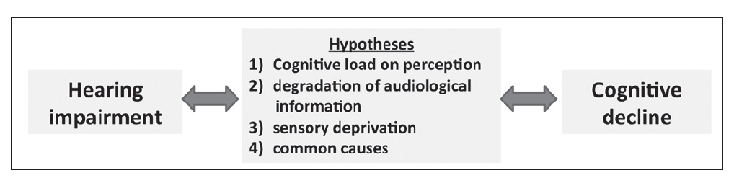

### 1.2.2 Current Solutions

With intense research, it can be concluded that most current solutions are not based on building a system to assist with the problem but rather involve the dependence on visual perception. A common suggestion is the implement of panoramic mirrors. These mirrors can give the driver a better sense of the vehicles in their vicinity and augment their visual perception which is their main sensory for driving operations. 16 But based on research as stated earlier, the absence of auditory task engagement leads to poor performance in tasks. This is because both the visual and auditory sensory to provide a complete picture of awareness of the surrounding environment. 10 Therefore, a solution based heavily on visual perception might not be ideal and would overload the cognitive ability of the driver leading to dangerous consequences.

### 1.2.3 Social, Economic, and Environmental Impacts

Hearing impairments in general can cause the individual to be socially isolated, and to experience low morbidity, morality and quality of life.[3] Adding further to the existing burden, these individuals are at a risk of not being fully alert to the surrounding noises and therefore being a risk to themselves and the people around them. These factors lead the individual to have a weak sense of community belonging and loneliness.[3] A study performed in 2008/2009 on a group of individuals aged 45 or older reported that 246,857 out of the 864,000 could not hear what was said in the presence of a hearing aid.[3] With this in mind, enhancing hearing aids being in use would not increase the confidence of drivers with hearing impairments. It is believed that bettering one of the aspects of their environment would encourage individuals with hearing impairments to improve their isolated lifestyle.

The anticipated design is not expected to add to the currently existing environmental burden. Most of the preliminary designs discussed in this report involve the use of pre-existing parts in the vehicle, apart from the sensors needed to collect information from the surroundings. Once the team selects the sensors needed, a life cycle assessment (LCA) will be performed to investigate their effect on the environment.

From an economic standpoint, our system should be beneficial to the people and the government alike. Reducing road accidents means spending less money on repairing damaged vehicles; similarly, the government would also spend less money on fixing the environment where an accident would take place.

## 1.3 Scope of Project

*Hear House*’s objective for this project is targeted to address a problem that is associated with hearing impaired individuals that drive vehicles. The project aims to tackle the discrepancies that occur to hearing impaired drivers on a daily basis. The obstacles impaired drivers face is a safety hazard to them and communities around the world. These being, the incapability of hearing a first response siren and therefore failure to immediately and effectively give way. Our intention is to minimize the margin of risk between a healthy driver and a disabled one. This is to be done without accumulating more stimuli to the driver. The target audience are car owners with hearing impairments and modern car manufacturers around the world that can utilize the design to further improve the safety of a driver. Meanwhile, the system is proved to be extremely beneficial to the common public, and thus could be potentially used by a larger demographic than initially targeted.

The system being designed should be able to and detect analyze the different sounds occurring in the driver’s vicinity and detect the siren from certain specified distances. It should also account for alterations like the Doppler Effect, and still accurately detect the siren signal. A successful system would alert the driver only when a siren sound is detected and would be able to disregard any other noises such as car engines, honks and human voices. Furthermore, the system will be designed such that it does not add to the already existing visual burden that drivers with hearing impairments experience. This is primarily targeted in order to avoid an excessive and unnecessary cognitive

Load that will further distort the driver’s mental capabilities to appropriately respond to the circumstance.

## 1.4 Constraints and Criteria

To clearly identify the objective of this design proposal, the following criteria and constraints are presented in **Table 1** and **Table 2**, respectively, to enable the team at *Hear House* to attain the best solution that satisfies all dimensions of the hearing impairment and driving problems. Both tables give a brief description and justification as to why they were chosen to be part of the design process’s objectives upon which the pillar of the project will stand. The best solution *Hear House* can develop and present, is one that will be able to satisfy all the topics presented below.

**Table 1:** The criteria developed for the project

|  |  |  |
| --- | --- | --- |
| **Criteria** | **Description** | **Justification** |
| User-friendly | *Interactive* | Older and younger drivers must not find it difficult to operate the device or integrated system |
| Cost-effective | *Affordable* | System should be available for a hearing-impaired individual in the middle class to purchase |
| High quality | *Appealing, yet Effective* | Designed system should be appealing, yet effective and highly reliable and possess high quality to grab the buyer's attention |
| Maximize safety | *Assurance Driver’s Safety* | Hearing impaired driver should have a sense of safety while operating the vehicle, and thus driver must feel system is highly reliable |
| Efficiency | *Should easily be able to grab the attention of the driver* | System should be able to detect 100% of the information needed by the driver |
| Minimize response time | *System should be able to provide alert in a minimal time frame* | System should be able to provide alert in a shorter period of time than it takes the average human being, in order to be effective |
| Several sensory for message communication | *Should input the desired message via more than one sensory stimulation* | System should be able to communicate with user via various sensory inputs in order to maximize safety and account for any cognitive or sensory distraction |
| Minimize mass and size | *System mass and size should be minimized to easily install* | Team and car manufacturers must be able to implement system “invisibly”; without any visual distortions to the car’s aesthetics |
| Minimize risk of failure | *Components should possess low risk of failure* | Products used must be of good quality in order to minimize risk of failure, and possess high computational power in order to accurately detect siren |
| Minimize complexity | *Should be simplified as much as possible* | A simplified design would provide the team and car manufacturers an improved easiness of fixing the system in the case of system’s failure |
| Maximize signal detection area | *Should be able to detect sirens in a reasonable distance* | Microphone should be able to capture signals that are of important and reasonable distance from the car in all directions, in order for design to be effective |

**Table 2:** The constraints developed for the project

|  |  |  |
| --- | --- | --- |
| **Constraints** | **Description** | **Justification** |
| Must be able to differentiate between different noise out puts | *Sound of a siren vs. surrounding noises* | Sensors must be able to detect different frequencies, pitch and patterns (depending on the country’s standard siren type used) |
| Must not be distracting to the driver | *Must be succinct* | Driver must not be distracted while on road by unnecessary functions  within the vehicle |
| Must possess high Durability | *Greater than 10 years* | Product must be able to withstand harsh weather conditions if integrated on the exterior of a vehicle |
| Electrical Canadian Code,  Professional Engineering Ontario (PEO),  ISO - 14001, TS16949, 9001,  International Automotive Task Force (IATF),  Health Canada Medical Device Regulations (CMDR)  Accessible | *Must be approved* | Product must be approved and safely operate according to necessary safety regulations, in order to able to sell to client |
| Must be compatible | *Available for all car models* | System must be available for purchase by both the car manufacturers and the driver |
| Must account for Doppler Effect | *Must be able to account for various influences that the factor implies* | System must integrate Doppler Effect considerations in the filtration process |
| Must use car battery | *Must be compatible with standard car battery as power supply* | System’s primary source of power supply is the car battery, and thus the design should utilize the standard 12-V car battery, and not exhaust it |

# 2.0 Design Solution

## 2.1 Design Process

The design approach implemented by the *Hear House* team firstly involved the execution and development of three distinct ideas and design concepts. The designs were independently developed through various brainstormed ideas provided by team members, and further enhanced to suit the design’s objectives. All three designs were tailored to satisfy the outlined criteria and constraints. The primary aim was to develop alternatives that would alert the user through various sensory pathways, and thus they all are governed by a siren detection system. Nonetheless, testing of which solution provides the most effectiveness for the intended usage had to be completed. The optimal solution is one that will allow for the achievement of the intended usage, as well as provide space for creativity and innovation for further development. The major aspects of the selection process involved the examination of each solution’s costs, feasibility, durability, associated risks, design impacts, as well as the easiness of usage. Decision matrices were constructed to assist in comparing the alternatives, and thus help highlight the optimal design (see **Appendix B**).

## 2.2 Prospective Design Solutions

### 2.2.1 Design Solution One

A proposed design for increasing the awareness of drivers with hearing impairments with their surrounding is improving hearing aids. The general outline of the proposed idea’s sketch is as seen in **Figure 1**. To begin with, hearing aids while extremely useful to some, they might prove less useful for those who suffer from higher levels of deafness or sensorineural hearing loss. Hearing aids are known to partially overcome the hearing difficulties that an individual face in their daily lives. For those with sensorineural hearing loss, noises detected by hearing aids are either audible, inaudible and some are a combination of both.17 This depends on the spectra of the noise being detected, if it is out of range, the hearing aid won’t detect it and vice versa. The spectra of some sounds partially audible and therefore won’t be correctly identified due to the inaudible section.17 Moreover, many users to do not prefer to wear hearing aids as they do not wish to be interpreted in their communities as suffering from a disability.7

Considering the improvement of hearing aids as the primary solution needs extensive knowledge in controls engineering and signals analysis. With this knowledge, the aids could be made such that higher frequencies are detected and background sounds in a noisy environment can be filtered and conversations can be amplified.18 The proposed design will allow the detected siren signal to be the only sound the user hears, and will block all other noises, in order to notify the user. From a cost point of view, the price of a hearing aid ranges from $1500 to $3500.19 Further improvements of hearing aids would require a larger team of engineers, more equipment and a test subject. Furthermore, it may potentially require a new manufacturing line for our brand’s hearing aids, in order to provide the team, the freedom to tailor the hearing aid to its intended usage. This would mean that the *Hear House* design team would require a much larger capital, most of which would be directed for research and development. Therefore, the design team deemed this solution unfeasible for functionality and cost factors.

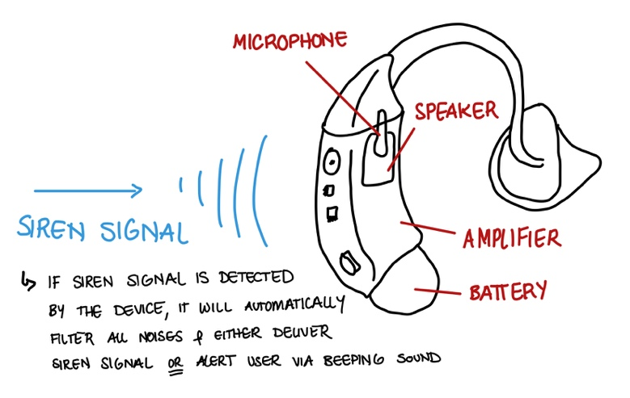

**Figure 1:** A brief sketch of the enhanced hearing aid to be developed by the team.

### 2.2.2 Design Solution Two

A simple form of communication between a driver with hearing impairments and their vehicle is through the implementation of haptic technology. This would involve the use of a simple electric motor that would cause the steering wheel to vibrate. The electric motor would be activated based on the signal analysis which would detect the presence of a siren. While this can prove to be an effective alert system, is not sufficient because auditory and visual perception are what a driver replies the most on. Additionally, it cannot be relied on as the primary source of alert communication with the usage, since any steering wheel does vibrate and quiver with any road turbulences. Thus, an easily distinguishable vibration pattern must be developed, in order to avoid any confusion that the driver might experience between a normal steering wheel quivering and the intended alert.

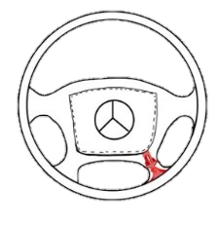

Figure 2: vibrating motor

### 2.2.3 Design Solution Three

A mentioned earlier in the report and through extended research it was concluded that drivers with hearing impairments rely heavily on their vision for safe driving. Therefore, the third suggested design solution involves targeting vision as the main form of communication between the driver and their surroundings. Communication can be achieved through either the head up display, built in GPS screen or a mobile application. The alerts would be designed such that they don’t add to the already existing burden the driver places on their vision.

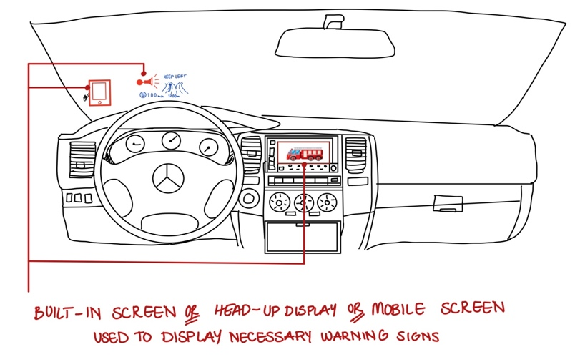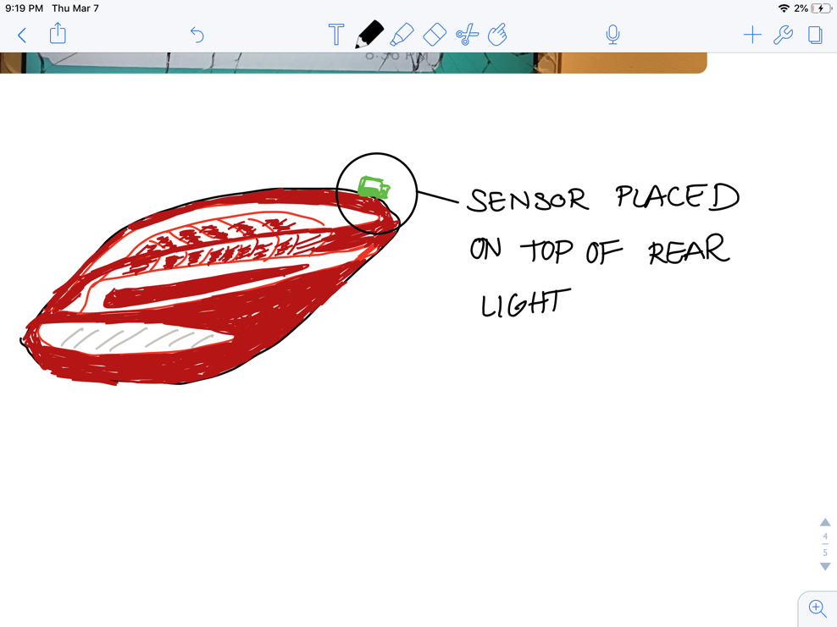

Figure 3: output display & sensor placment

## 2.3 Detailed Final Design

### 2.3.1 Mechanisms, Components, and Tools Required for Selected Design

*Hear House*’s selection of a siren detection system utilizing a visual alerting/stimulating message was the optimal design solution for the intended usage (see **Appendix B**). The solution was further developed and the major components required for the successful execution of the design were briefly outlined in **Table 3,** accompanied by a brief justification of their roles. Nonetheless, the team was concerned with the factor of safety regarding any unexpected disturbances or distractions that result in the failure of the driver noticing the visual message. Hence, an alternative alerting system was utilized to account for such factors, and it involves the use of a haptic alerting system that will notify the user through an easily distinguishable vibration in the steering wheel.

**Table 3:** Necessary components of design and their corresponding roles.[35]

|  |  |
| --- | --- |
| **Component** | **Role** |
| Microphone | Input the necessary signals into system, and potentially amplify the sound signals for easier siren signal detection |
| Analog-to-Digital Conversion Processor | Required to convert the analog signal into a digital form for filtering and signal processing |
| Filter Processes | Used in order to fabricate the signals received by the microphone, and limit the frequency levels |
| Digital Signal Processing Processor | Most computational power required; receives digital signal from ADC and analyzes the intensity and frequency captured by microphones |
| Microcontroller | This unit will be the brain of the system. It will control the whole system. |
| Power Supply | Standard 12-V car battery should be sufficient to provide the required power supply to all parts |
| Wires | The wires are used to connect the system together; Each car will use an average of 5.5M of wire |
| Voltage Controller | Used to control the voltage from the car battery to system |
| Heat Shrinks | Used for electrical safety |
| Mobile Application | Will be used to provide the visual alerting message using bright and flashing message(s) |
| Steering Wheel Haptic System | Will be used to provide the vibro-alerting message using easily distinguishable vibrations |

To provide a better insight into how the system’s components are integrated, **Figure 4** was constructed to provide a general schematic of how the necessary components are connected. The alarming message will be through the usage of the visual and/or haptic stimulation, as previously discussed. Furthermore, Mobile Application Developers will be working alongside the team to develop the mobile application that will notify the user of the presence of an emergency siren. They will be required to develop an application that overrides any phone activities, and only turn the phone screen “ON” when a siren is detected through the system. Therefore, if a siren signal is detected by system, an immediate response will take place through the display of an alerting message that overrides any other mobile applications. Moreover, the phone’s brightness will be increased to its maximum, with bright and easily distinguishable colours (such as red, orange, or yellow) will be used in a flashing manner to notify user. This will prevent the user from having his/her mobile phone being in use through his/her driving trip, and thus will save the unnecessary consumption of the phone’s battery.

**Analogue Siren Signal**

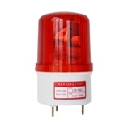

**Microphone**

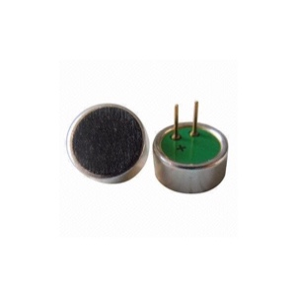

**Butterworth Filter**

XLR Connection

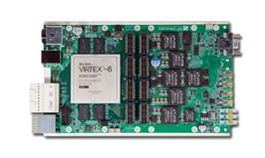

**DSP Processor**

**Analog-to-Digital Converter**

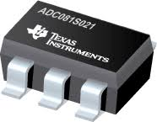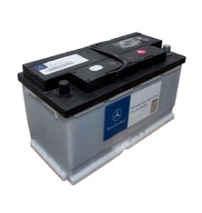

**12-V Standard Car Battery**

0-5V Input

0-5V Input

**Alert/ Stimulus Message**

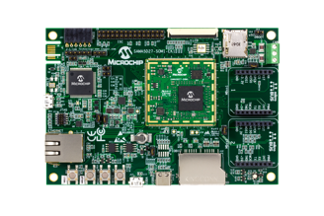

**Microcontroller**

**Figure 4:** A general schematic of the integration of system's components.

Utilizing components of such high computational power should limit the response time of the system to approximately 5 seconds. Unfortunately, solid calculations could not be thoroughly outlined as intensive knowledge of each component is required. Nonetheless, through various research conducted, the system should respond in less than 3 seconds, but the team will account for a factor of safety and claim the response time as being 5 seconds. Meanwhile, the average human being takes about 10 to 15 seconds to detect a siren signal.13 The reason is contributed to the playing of loud music, inattention, cognitive distractions, or the difficulty in older individuals in taking a logical decision in a short period of time.15,17 Therefore, the usage of the system should be of extreme benefit for users of various demographics.

### 2.3.3 Microphone

F Microphones are a crucial component of this system. They are devices that will input the surrounding sound signals, and amplify the signal for easier filtration process. Important considerations regarding the number of microphones used, the desired degree of overlap in pickup patterns, as well as the physical placement position in the car model. Utilizing three microphones will minimize the cost, however, will provide a triangular pickup pattern which possesses less precision than a square pattern. Since our system aims to detect the siren signal with high accuracy, as well as determining the location of the siren, four microphones will be used to cover the 360°, with an accuracy of +/- 45°.[35]

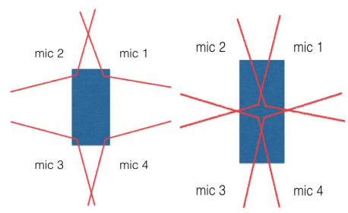 The four microphones utilized will have their diaphragms facing outwards and will be ideally placed in an invisible position to account for the car’s aesthetics**. Figure 3** illustrated the drastic difference between the position of the four microphones, and their effects on the pickup area.

**Figure 5:** The difference in pickup patterns in two different microphone placement configurations.

The system will have the microphones placed in a square configuration in order to create an empty center between microphones. This will result in the triangulation of the origin of the desired signal. This void ensures that one microphone will always not be in use. Thus, it cuts the angle of pickup area by approximately 180°, without influencing the amplitude comparisons. As a result, the removal of one microphone from the system will allow the decision logic to be completed more rapidly by the system, in terms of amplitude calculations.

There are two major types of microphone responses, which are the flat and tailored responses. The tailored response results in a built-in gain for certain range of frequencies. This is beneficial since they can be used to detect and amplify only the siren signals possessing the desired frequencies, causing a filtration of noises and thus a larger response. Nonetheless, it is very costly and require customized microphones to be manufactured. Thus, the chosen response if the flat response, which provides a uniform response to all frequencies captured by microphone. However, different microphones may not provide an identical and uniform responses. For our intended usage, the siren detection system should be consistent with a frequency response between 500 Hz and 3000 Hz. The triangular algorithm previously discussed should take into consideration any difference that may be present in the frequency range. Thus, the optimal option necessitated that we select a microphone of an extremely flat frequency response.

There are two types of microphones that depend on their diaphragm’s design. These are the dynamic and condenser microphones. They both convert sound signals to electric signal in similar ways, however, the two use differing transducers. Condenser microphones are intended for a better-quality audio fidelity, however, are very delicate. On the other hand, the dynamic microphones are less sensitive, yet much more tolerant of surrounding vibrations. Since our system will undergo and experience random rigorous vibrations, and harsh weather conditions from winds to rain, dynamic microphones make a solid choice for the intended usage.

Lastly, our microphone has now been selected to be a dynamic microphone with a small cardioid pickup pattern (makes best overage of surrounding area for four microphones), a frequency range of 500 Hz to 3 000 Hz, and a very flat response. Most microphones have a 50 Hz to 20 000 Hz frequency range, and thus the team will focus on the quality of the microphone in terms of the angle of view required, as well as the linearity of the frequency response desired. Comparing between the Sennheiser e604 and the Shure SM58, the qualities of both models were very good, yet the price varied drastically. Outlined in Appendix C are the two models’ specifications, and accordingly the Shure SM58 model was successfully selected to be the optimal model for the intended use.

### 2.3.4 Analog-to-Digital Conversion Processor

In order to process the incoming signal an analog-to-digital conversion is required. For this type of conversion, a sampling rate of 42 kHz is required. This sampling rate will be ideal for this system as it will provide the system with enough information for it to process and detect the siren in time. The ADC chip to be used for this system is the Texas Instruments ADC081S021. This chip will be ideal for the system as it will convert 8-bit resolution therefor the DSP will have 256 points to work with. Having a 16-bit convertor is more precise for performing signal processing. For an emergency vehicle siren, the signal is simpler due to the repetitiveness and therefore and 8-bit would be ideal. This unit is cheap and consumes low power (low power device). The sampling rate of the chip is between 50Ksps to 200ksps.

### 2.3.5 Filtration Processes

Before the system reaches the signal processing stage, it needs to go through a filtration process. The filtration process makes it easier for the processors to recognize the signal frequency and pattern. It will also decrease the processing time of the signal which in return will decrease the response time. Three filter types were considered, Active, Passive and a Butterworth filter. The table below shows the specifications for each of the filters.[35]

|  |  |  |  |
| --- | --- | --- | --- |
| Type | Number of processors | Power | Out of band filtering (dB/Decade) |
| Active | 0 | Needs external power supply | 20 |
| Passive (1st Order) | 1 | Low power device | 20 |
| Butterworth 5th Order | 8 | Low power device | 20 * 5 = 100 |

Table 4: Types of filters

After further research, it was concluded that a 5th order ButterWorth filter was suitable for this system. This filer was chosen based on the number of processors used. Furthermore, the ButterWorth filter uses 100 dB/Decade which is what the system needs. The circuit design of the ButterWorth is demonstrated in Figure 6. The low pass and high pass ButterWorth filters are connected in series which creates a Band pass ButterWorth filter as shown in figure 6.

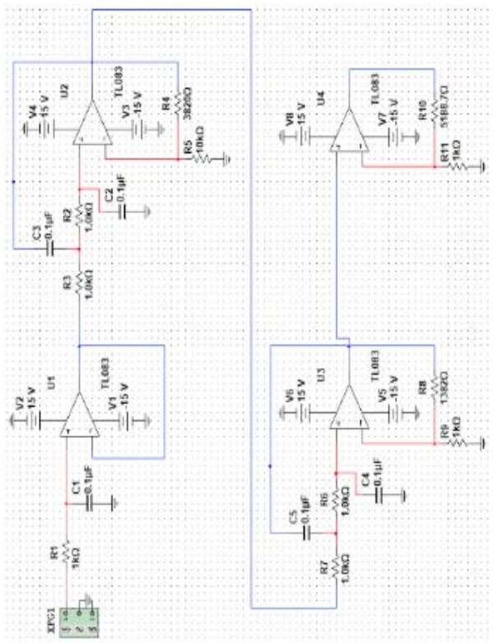

Figure 6: Circuit of ButterWorth filter[35]

### 2.3.6 Digital Signals Processing

The Digital Signal Processing is crucial element of this design, there are several parts that need to be considered in order to ensure it is functioning correctly. These include the sampling rate, Bit resolution, processing speed and lastly power consumption. [35]

The sampling rate is the simplest to deal with because the siren has a unique frequency and cycle. As mentioned before the sampling rate that is chosen is, 256 at a sampling frequency of 42 kHz. This rate will allow the system to detect up to 21 kHz. The siren frequency ranges from 500 Hz to 3 kHz which is low and possibly every chip in the market is compatible for this range.

For bit resolution, the system was designed for an 8-bit resolution. As mentioned earlier, due to the characteristics of the siren signal it is very easy to detect it. Using a 16-bit will give it more accuracy and minimal change in processing speed. It is an improvement that can be considered for future work.

Figure 7 shows the flowchart of the system. This was taken from a previous research that was conducted by Ryan Chappel, Daniel Christiano and John Fick in Fall 2015**[35]**. The diagram outlines a brief flow of the system and was chosen based on its similarity with our system,

For power consumption, DSP chip uses low power consumption it was found from the data sheet to be around 1 mW/MHz.

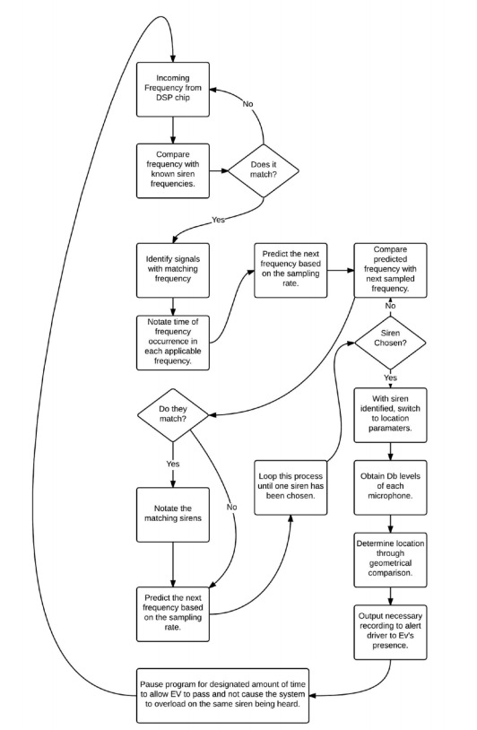

Figure 7: Flowchart of the system

### 2.3.7 System Power Supply

The system’s power supply will utilize the car battery. Thus, some constraints on the extent of power drawn from the battery must be set. If the system were to be running outside a car, it will certainly need a battery source. Nonetheless, in an actual car, the system will be directly connected to the car battery, that will be charged by the running car. Since all car batteries in the automotive industry currently use batteries of an average 12-V power, thus, our system will be designed to be suited with such a power supply.

Since we do not desire to have our system run constantly as this will drain the car battery, a mechanism of turning the system on has to be accounted for. This will require that we include a switch in our system that will activate the devices used, just like the action of turning a car on. This can be done by connecting the positive leads of the batter into a switch that will activate the positive terminal of the battery. From the system’s size and complexity, one switch will be used sufficiently to turn the entire system on and off.

### 2.3.8 Bluetooth Module

For the purpose of this system, it is expected that user’s phone will be present with them while they operate the vehicle. Therefore, a connection between the system of sensors and the mobile application can be established using Bluetooth. This can be achieved by attaching an HC-05 Bluetooth module to the controller. This Bluetooth module has a range of 10 meters, which is sufficient for the purpose of this system. The module would be directly connected to the controller being used.

The role of the software developers would be to create an application that can perform three main functions. First, it should be able to show the user the list of Bluetooth connections in the area and allowing them to select and connect to the desired network. Second, the main screen should be a siren bulb image that can flash when an emergency vehicle is approaching. Lastly, the application should be programmed such that it can override any running application such as the GPS or a phone call screen.

### 2.3.9 Steering Wheel Haptic Alert

The steering wheel haptic alert system is very simplistic, as it utilizes the same decision logic as the visual alert. However, the microcontroller will be required to send a signal to the vibration motors attached in the steering wheel. The implementation will depend on the model of the car, and whether the haptic system is already existent in the steering wheel or not. If it were, then this will only require that we connect it to the microcontroller, with the help of the car manufacturers, and choose an easily distinguishable vibration pattern. Research is yet to be completed using hearing-impaired audience in order to identify the easiest vibrational pattern to be recognized and differentiated in the shortest time possible.

Meanwhile, if the car model does not possess a haptic system, a simple electric motor will be placed as seen in Figure 5, utilizing a 7-V to 12-V power supply, depending on its power. These motors should be able to successfully respond to the microcontroller with a 93% accuracy, and a reasonable reaction time of approximately 7 seconds. This still lies with the desired range of response time. However, this implies that the visual alert will most probably be first to alert, then followed by the vibro-alert.[36][37]

## 2.4 Cost of Design Implementation

The three primary costs that will not be accounted for in the loan taken from the bank, are the labor, maintenance, and material costs. The maintenance costs are primarily concerned with the labour annual costs, as the maintenance is primarily concerned with the checking of defective parts. Since the lifetime of the system is durable, maintenance costs are expected for the replacements of small defective components, and thus no solid information could be provided. Additionally, labor costs required for maintenance of mobile application is accounted for. **Table 4** summarizes the costs.

Therefore, it could be concluded that the total capital costs including the design labor costs, total to approximately $ 448 307.14. These figures were calculated using worst case scenarios. Hence, a loan from an average Canadian Bank will provide this loan for a 7.25% annual interest rate with a repayment period of approximately 5 years. Therefore, it necessitates the payment of $ 9 959.68 monthly, accounting for the total interest costs. Therefore, the price of the units has to be able to produce a profit, and cover the materials and annual labor costs.

In addition, it is reasonably assumed that Mercedes-Benz implements the system in 1% of its total car manufacturing output, and the team profits a 10% of each unit sold. The team is currently not concerned with the price markup the manufacturer will assign, but rather a 10% profit of each unit sold. Car manufacturers will most probably source their own material and labor stream. Thus, it is reasonable accounted that the car manufacturer will markup the car’s price by a minimum of $2 000.00. Therefore, the team wishes to profit $ 200.00 from every unit sold via the car manufacturer. Given that Mercedes-Benz sold approximately 2.3 million cars worldwide in 2017, the manufacturer can implement the system in approximately 23 000 cars per year. This accounts for a profit for *Hear House* of approximately $4 600 000 per year. Meanwhile, the unit price is set to an exact $1 500 when built independently by our team. Therefore, the payback period is 3.98 years and 0.12 years, respectively.

Table 5: Summary of all necessary project costs.

|  |  |
| --- | --- |
| Cost Type | Total |
| Capital | **$ 418 406.00** |
| Annual Labor | **$ 653 998.00** |
| Design Labor | **$ 29,901.14** |
| Unit Material Cost | **$ 1 286.97** |

# 3.0 Design Defense

## 3.1 Primary and Secondary Functions

Our system integrates a primary function that would be available for all hearing-impaired drivers. This function would be widely available to target the 25% of hearing-impaired drivers that actually wear there hearing aids while driving and the 75% of those who don’t as well. Moreover, our system could also be implemented and offered as an extra feature for vehicles targeting drivers who choose to take extra precautions to be safer on the road. It would include a secondary function targeting drivers who listen to loud music while driving. A Canadian study proved that the reaction time decreases by approximately 20 percent for drivers who play loud music while driving.[20] As a result, our system could provide those drivers with a safety precaution that would be able to quickly alert those drivers through the phone application as well as the vibration unit that would be implemented in the steering wheel. It would be able to alert those drivers through the phone application as well as the vibration unit that would be implemented in the steering wheel. Therefore, targeting customers who choose to be safer on the road are an ideal audience for the implementation of this design.

Furthermore, the team, alongside the car manufacturers, will certainly invest efforts in marketing the design as a necessity for the general public. Thus, if successful, it can drastically influence the sales and revenues of the product. Accordingly, the degree of success of the project will provide a solid indication on the enhancements and additional features to be added to the system that will potentially be of a great benefit to any driver.

## 3.2 Safety and Regulations Aspects

Our system includes features that offers safety to impaired and non-impaired drivers as well. These features aim to instill a sense of safety for the drivers while operating the vehicle. Taking into consideration that this design does not involve major mechanical calculations, to be accounting for extra loads or stresses. Instead, a different approach is used to implement additional safety features. A touch sensory vibration unit will be added to the steering wheel to account for any flawed connection within the cellular device. This unit will act as an additional alert to the driver in case he/she gets distracted on roads. Furthermore, our team decided to integrate the use of a voltage regulator to ensure the voltage stays within specified range and does not fry our computer. Our system also includes additional backup microphones to account for any malfunction within the other operating sensors.

Meanwhile, several codes and regulations must be carefully followed and implemented. Thus, to account for the various essential regulations to be followed, **Table 4** was constructed to outline the necessary ones and their corresponding description.

|  |  |
| --- | --- |
| **Codes & Standards** | **Description** |
| **ISO 14001** | The design needs to follow the international standards for environmental safety. This system was designed with environmentally friendly materials with minimal carbon emissions. |
| **ISO/TS 16949** | The design needs to meet the safety standards for automation. It was met by minimizing the distraction on the driver and increasing the safety of alerts. |
| **Professional engineering of Ontario (PEO)** | The stages of the design need to meet the professional standards of engineering in Ontario. It was met by following the regulations of design in a proper way and by maintaining professional communication within the team. |
| **Canadian Electrical code (CE)** | The design needs to meet the safety requirements for circuit design. It was met by designing circuits with high safety and adding break switches to avoid the danger of excess voltage or current. The regulation was followed precisely from the website. |
| **International Automotive Task Force (IATF)** | The design will require the approval of IATF to be added to the client presented. |

Table 6: Codes and regulations that need to be met, and their respective description.

## 3.3 Economic Impacts

Hear House would initially start as a small business, the backbone of the economy. The company could greatly impact its society if it purchases needed material and components from local suppliers.

## 3.4 Environmental Impacts

For the majority if our design, the system proved to be environmentally friendly because it does not involve the release of carbon emissions and such heavy gases. The only environmental impact that would be present is that coming from the recycling of the vibration sensors after replacing them for a defect, physical damage, or if the user wishes to disassemble the sensors. Electronic recycling or otherwise known as e-waste has a very specific recycling process. After the electronic waste arrives at the recycling facilities, it is shredded and sorted to divide up the plastic components of an electronic from its metallic components.[21] These raw materials would then be available for sale to develop newer products. However, our sensors are very small electronic devices, therefore it is safe to assume that it falls within the 15-18 percent of electronic waste that goes to landfills. Our sensors would not significantly affect our environment, but if disposed improperly and in large amounts, it is harmful to the environment. Moreover, e-waste releases toxic chemicals into sea waters and affects aquatic and land-living animals.[22]

# 4.0 Risks and Uncertainties

To assess the project’s feasibility and analyze whether launching and implementation of the design solution is of a significant benefit to either the company the project is proposed to or *Hear House*, various aspects have to be accounted for. Firstly, looking at the price per unit as determined (see **Appendix C**) to be approximately $1 500.00, as well as the capital and running costs of the project, it can be assumed that the 15% net profit rate is a very significant margin to allow the project to be categorized as a successful project.

Nonetheless, since *Hear House*did not yet test the idea in the market and gather surveys and data on the expected units to be sold, the total revenue cannot be yet determined. However, the price calculated was solely based on selling 100 units per year, which equals approximately 8 customers per month. Should a marketing campaign be able to attract a bigger population, and effectively target the customers intended for this project, the company can either be able to reduce the price per unit or increasing its revenue as more units are sold. However, the exact number of customers is a risk that has to be accounted. Thus, to account for this risk, a minimum of 100 systems are expected to be installed in a year, which should safely cover the capital costs and labor costs within a maximum of two (2) years.

Nevertheless, many other factors are involved in the risk management and sensitivity analysis of the project. However, the main factors that may shape some kind of risk on the project are the prices of materials, the change in currency, border tax if materials were to be sourced from outside Canada, and if the different labor costs if the company were to implement the project outside Canada. The entire report is written based upon Canadian dollars as of the submission date of this memorandum. Thus, fluctuations may happen to the value of the currency as a result of economic changes. However, *Hear House* has assessed the fluctuation of the Canadian dollars in comparison to the American dollars, and fluctuations do not shape a significant risk to the business’ relatively small-scale entity. If the Canadian dollar’s value were to change, the material costs and labor costs are also expected to change across the entire country. Thus, at this point, the team will have to reassess either the price per unit sold or the expected revenue percentage to account for this risk.

On the other hand, if the team were to source materials from outside Canada for significantly lower prices, the Canadian Border Tax has to be accounted for, and a reassessing of cost versus revenue calculations will have to be made. This will either result in the change in unit price or increasing the target revenue figure. Furthermore, if the project were to be implemented outside Canada, such as in the Mercedes’ headquarters in Germany, then labor and materials costs are set to change according to the salaries and materials’ prices in Germany. This however can be accounted for using the same action as mentioned in previous cases.

Since the business is considered a small business according to the Canadian government, the change or adjustment of tax or interest rates will only become a major concern if the business were to begin making significant profits that start to categorize it as a large business. However, since no exact total revenue figures are currently available, such a risk will have to be accounted for once the company start to market and sell its design, and by then the team will be able to set a maximum number of units sold before the business is categorized and treated according to large businesses.

# 5.0 Conclusions and Recommendations

By evaluating the different design parameters and further specifying the technical components of our design, Hear House was able to develop a complete functioning design. Cost analysis as well as sensitivity analysis were performed to better understand the variations of design parameters and how they directly or indirectly affect our design. With the consideration of labor and maintenance costs, it was calculated that the capital cost for this design was $418,406 CAD with a payback period of 3.98 years. Different safety components if our design was presented through additional safety components that were integrated in the design. These include a touch sensory vibration unit, a voltage regulator, and back up sensors. The design defense was provided considering the different social, economic, and environmental impacts. By following a set of constraints and criteria, Hear House was able to develop a concept for a fully functioning design.

As with any new and upcoming system, the design team has prepared a list of recommendations that can make the product superior. To begin with, once the system has proven successful, it can be implemented within the car itself through the car manufacturer. It can communicate with the user through the built in GPS screen or head-up display. This is critical for growth and for keeping up with technological advances in the world.

Another recommendation involves the use of 16-bit resolution instead of an 8-bit resolution. This will enhance the accuracy of the system. The only drawback is the increase of the processing time which is very minimal in which it can be negligible.

Achieving a safer system could be made possible through making it such that the signal analysis can be for car honks as well. Driver are usually alerted and drawn attention to using the only source of communication between drivers, the car’s honk. 3 Car honks can be used to warn about mistakes that include drifting off of the roadway or mistakenly turning and passing when it is not the driver’s turn. Since it is established that honks have a crucial role while driving, it is unsafe to have the driver not be able to decipher the alarming noise of the honk, assuming the driver suffering from a hearing impairment is engaged in any means of distraction. Hear House aims to incorporate signal analysis that includes both car honks and emergency sirens. A successful analysis of the signals being attained by the sensors would be able to differentiate between a car honks, emergency siren and eliminate any other noises present in the surrounding.

Driving is accounted to be a daily activity that is crucial to any population, yet if life-threatening activities were to be present during the driving process, many crashes and deadly consequences can take place. 3 Distractions that include drifting off of the roadway or mistakenly turning and passing when it is not the driver’s turn, are some common mistakes performed by every driver, that are usually alerted and drawn attention to using the only source of communication between drivers, the car’s honk. 3 Therefore, car’s honks are the primary communication tool between drivers, and its crucial role makes it unsafe to have the driver not be able to decipher the alarming noise of the honk, assuming the driver suffering from a hearing impairment is engaged in any means of distraction.

# References

[1] Facts and figures. (2018, March 12). Retrieved January 25, 2019, from <https://www.chs.ca/facts-and-figures>

[2] Three million Canadians suffer from hearing loss. (n.d.). Retrieved from https://www.hear-it.org/three-million-canadians-suffer-from-hearing-loss

[3] Ramage-Morin, P. L. (2016). Hearing Difficulties and Feeling of Social Isolation Among Canadians Aged 45 or Older, 27(11), 3-12. <https://pdfs.semanticscholar.org/f738/8f342b5bd91154e493ebe5da77a115aaf04d.pdf>

[4] Yasmin, S., Anowar, S., & Tay, R. (2014, July 04). *Injury Risk of Traffic Accidents Involving Emergency Vehicles in Alberta*. Retrieved March 29, 2019, from http://ctrf.ca/wp-content/uploads/2014/07/4YasminAnowarTayInjuryRiskofTraffic.pdf

[5] Hamilton, P. T. (2015). Communication through Distraction: A Study of Deaf Drivers and Their Communication Style in a Driving Environment (Master's thesis, Rochester Institute of Technology, 2015) (pp. 1-82). Rochester, NY: Rochester Institute of Technology.

[6] Lee, Y., Lee, J. D., & Ng Boyle, L. (2007). Visual Attention in Driving: The Effects of Cognitive Load and Visual Disruption. Human Factors: The Journal of the Human Factors and Ergonomics Society, 49(4), 721-721.

[7] Bavelier, D., Dye, M. W., & Hauser, P. C. (2006). Do deaf individuals see better? Trends in Cognitive Sciences, 10(11), 512-518. doi:10.1016/j.tics.2006.09.006

[8] Zhang, Y. (2011). Visual and Cognitive Distraction Effects on Driver Behavior and an Approach to Distraction State Classification (Master's thesis) (pp. 1-184). Raleigh: North Carolina State University.

[9] Sladen, D. P., Tharpe, A. M., Ashmead, D. H., Grantham, D. W., & Chun, M. M. (2005). Visual Attention in Deaf and Normal Hearing Adults. Journal of Speech, Language, and Hearing Research, 48(6), 1529-1537. doi:10.1044/1092-4388(2005/106)

[10] Herbert, N. C., Thyer, N. J., Isherwood, S. J., & Merat, N. (2016). The effect of auditory distraction on the useful field of view in hearing impaired individuals and its implications for driving. Cognition, Technology & Work, 18(2), 393-402. doi:10.1007/s10111-016-0366-2

[11] Treisman, A. M., & Davies, A. (2012). Divided Attention to Ear and Eye. From Perception to Consciousness, 24-31. doi:10.1093/acprof:osobl/9780199734337.003.0005

[12] Wayne, R. V., & Johnsrude, I. S. (2015). A review of causal mechanisms underlying the link between age-related hearing loss and cognitive decline. Ageing Research Reviews,23, 154-166. doi:10.1016/j.arr.2015.06.002

[13] Fortunato, S., Forli, F., Guglielmi, V., De corso, E., Paludetti, G., Berrettini, S., & Fetoni, A. R. (2016). A review of new insights on the association between hearing loss and cognitive decline in ageing. Acta Otorhinolaryngologica Italica, 36, 155-166. doi:10.14639/0392100X-993

[14] Legislative Services Branch, G. (2018, December 29). Consolidated federal laws of canada, Medical Devices Regulations. Retrieved February 14, 2019, from https://lawslois.justice.gc.ca/eng/regulations/SOR-98-282/page-2.html#h-6

[15] International Automotive Task Force. IATF 16949:2016. Retrieved February 10, 2019, from <https://www.iatfglobaloversight.org/iatf-169492016/about/>

[16] Can You Drive If You're Deaf? (2018, May 24). Retrieved from <https://hearingsolutions.ca/can-you-drive-if-youre-deaf/>

[17] Hamacher, V., Chalupper, J., Eggers, J., Fischer, E., Koragel, U., Puder, H., Rass, U. (2005). Signal Processing in High-End Hearing Aids: State of the Art, Challenges, and Future Trends. *Journal on Applied Signal Processing,* 18, 2915-2929.

[18] Dillon, H. (2008). Hearing Aids. Retrieved from <https://dspace.nal.gov.au/xmlui/handle/123456789/773>

[19] (2019, March 28). Why Hearing Aid Prices are Inflated. Retrieved from <https://www.audicus.com/hearing-aid-price-bubble/>

[20] (2019, March 28) Study Loud Music Distracting Teen Drivers. Retrieved from https://www.hinsdalelawyers.com/blog/study-loud-music-distracting-teen-drivers

[21] Haque, T. (n.d.). Introduction to Electronics Recycling. Retrieved from https://www.thebalancesmb.com/introduction-to-electronics-e-waste-recycling-4049386

[22] Sadeghi, A. (2019, January 03). Effects of E-Waste On Our Environment. Retrieved from https://allgreenrecycling.com/effects-of-e-waste-on-our-environment/amp/

[23] CSA. (n.d.). CSA Store. Retrieved April 6, 2019, from <https://store.csagroup.org/?cclcl=en_US>

[24] PEO. (2019, April 2). PEO Fees. Retrieved from <http://www.peo.on.ca/index.php?ci_id=33328&la_id=1>

[25] I. (2015, September 01). ISO 9001:2015. Retrieved April 6, 2019, from <https://www.iso.org/standard/62085.html>

[26] Webmaster, A. (2019, January 1). AIAG Store. Retrieved April 6, 2019, from <https://www.aiag.org/store/publications/details?ProductCode=IATF2-K>

[27] EMERGO. (2019, January 24). CMDCAS, MDSAP and Health Canada ISO 13485 QMS Compliance. Retrieved April 6, 2019, from <https://www.emergobyul.com/services/canada/iso-13485-modifications-cmdr>

[28] Canada Revenue Agency. (2019, February 12). Capital cost. Retrieved April 6, 2019, from <https://www.canada.ca/en/revenue-agency/services/tax/businesses/topics/sole-proprietorships-partnerships/report-business-income-expenses/claiming-capital-cost-allowance/capital-cost.html>

[29] EDIS. (n.d.). What is a Pre-Engineered Building? Retrieved March 7, 2019, from <https://www.ediscompany.com/what-is-a-pre-engineered-building/>

[30] BUILDINGSGUIDE. (n.d.). Steel Warehouse Building | Price Estimates & Quotes. Retrieved March 7, 2019, from <https://www.buildingsguide.com/blog/planning-steel-warehouse-building/>

[31] KAUFFMAN CO. (2018, June 21). How to Estimate Fire Sprinkler System Cost. Retrieved April 6, 2019, from <https://www.kauffmanco.net/estimate-fire-sprinkler-system-cost/>

[32] THESPACEPLACE. (2018, August 29). Furniture Budget Pricing Matrix for Commercial Clients in San Francisco. Retrieved April 6, 2019, from <https://thespaceplace.net/furniture-budget-pricing-matrix/>

[33] Raley, T. (2019, March 02). How to Calculate Warehouse Storage Costs. Retrieved April 6, 2019, from <https://sciencing.com/how-5869978-calculate-warehouse-storage-costs.html>

[34] ULINE. (n.d.). Retrieved April 6, 2019, from <https://www.uline.ca/BL_3867/Wide-Span-Storage-Racks-Particle-Board>

[35] Chappell, R., & Christiano, D. (2015, December 10). *Emergency Vehicle Detection System*. Retrieved from <http://www.eecs.ucf.edu/seniordesign/fa2015sp2016/g28/Documents/Midterm%20Paper.pdf>

[36] Goryachev, I., Hanczor, M., Pratt, R., & Van Dyke, M. (n.d.). Haptic Steering. Retrieved from <https://www.mie.neu.edu/sites/default/files/pdfs/mie/Capstone/Mechanical_Engineering/ME_2013_04_Haptic_Steering.pdf>

[37] Hjelm, J. (2008, September). Haptic in Cars. Retrieved from <http://www.sis.uta.fi/~hui/mobile/papers/Hjelm-paper.pdf>

The following references were used all together to provide cost estimates and technical info for analysis and data throughout the appendices:

[38] Omnidirectional Electret 9.7*6.7mm 9767 Condenser Microphone - Buy Condenser Microphone,Condenser Microphone,Condenser Microphone Product on Alibaba.com. (n.d.). Retrieved from <https://www.alibaba.com/product-detail/Omnidirectional-Electret-9-7-6-7mm_60357962509.html?spm=a2700.galleryofferlist.normalList.326.253b1c32YWaqYh>

[39] Sae J1128 Gxl 18 Awg Automotive Cable / Wire - Buy Sae J1128 Gxl Automotive Cable / Wire,Automotive Cable,Cu / Xlpe Automotive Cable Product on Alibaba.com. (n.d.). Retrieved from <https://www.alibaba.com/product-detail/SAE-J1128-GXL-18-AWG-Automotive_60489160867.html?spm=a2700.7724838.2017115.203.4e1937c3HDijKF> <https://www.alibaba.com/product-detail/SAE-J1128-GXL-18-AWG-Automotive_60489160867.html?spm=a2700.7724838.2017115.203.4e1937c3HDijKF>

[40] 2017 New Intel J1900 Quad Core Ultra Low Power Thin Client Desktop Computer 2 Ethernet Fanless Ubuntu Mini Pc 12v With 4gb Ram - Buy Mini Pc,2 Ethernet Mini Pc,Mini Pc With 4gb Ram Product on Alibaba.com. (n.d.). Retrieved from <https://www.alibaba.com/product-detail/2017-New-Intel-J1900-Quad-Core_60596893449.html?spm=a2700.galleryofferlist.normalList.109.7cc35a7cca0xLR>

[41] C5505 eZdsp USB Stick Development Tool. (n.d.). Retrieved from <http://www.ti.com/tool/TMDX5505EZDSP>

[42] L7805cv Voltage Regulator To-220 L7805 7805 5v Positive Voltage Regulators - Buy Lm7805cv,Positive Voltage,Positive Voltage Regulators Product on Alibaba.com. (n.d.). Retrieved from <https://www.alibaba.com/product-detail/L7805CV-voltage-regulator-TO-220-L7805_62014867510.html?spm=a2700.7724838.2017115.136.29e322d1LHEL9r>

[43] Average Assembly Technician Hourly Pay. (n.d.). Retrieved from <https://www.payscale.com/research/US/Job=Assembly_Technician/Hourly_Rate>

[44] Average Quality Assurance Analyst Salary. (n.d.). Retrieved from <https://www.payscale.com/research/CA/Job=Quality_Assurance_Analyst/Salary>

[45] Average Mobile Applications Developer Salary. (n.d.). Retrieved from <https://www.payscale.com/research/CA/Job=Mobile_Applications_Developer/Salary>

[46] Tail Light Bulb Replacement Service & Cost | YourMechanic Repair. (n.d.). Retrieved from <https://www.yourmechanic.com/services/tail-lamp-bulb-replacement>

[47] Weisbaum, H. (2006, March 28). What's the life expectancy of my car? Retrieved from [http://www.nbcnews.com/id/12040753/ns/business-consumer_news/t/whats-life-expectancy-my-car/#.XIqOa6cZPfY](http://www.nbcnews.com/id/12040753/ns/business-consumer_news/t/whats-life-expectancy-my-car/)

[48] How to Test Your Auto Battery | Battery Testing & Maintenance. (n.d.). Retrieved from <https://www.autobatteries.com/en-us/battery-testing-and-maintenance/car-battery-voltage-and-testing>

[49] Moor, T. (2017, June 02). How Much Does a Car Battery Cost? Retrieved from <https://www.angieslist.com/articles/how-much-does-car-battery-cost.htm>

(n.d.). Retrieved from <https://www150.statcan.gc.ca/t1/tbl1/en/tv.action?pid=1810000101>

[50] Reserved., .. A. (2012, October 15). Interactive Map: The cost of electricity, city by city. Retrieved from <https://o.canada.com/business/markets/interactive-map-the-cost-of-electricity-city-by-city>

[51] Charging Plug-In Electric Vehicles at Home. (n.d.). Retrieved from <https://afdc.energy.gov/fuels/electricity_charging_home.html>

[52] Income Tax Calculator, Ontario, Canada. (n.d.). Retrieved March 10, 2019, from https://neuvoo.ca/tax-calculator/?iam=&salary=35.00&from=hour®ion=Ontario

[53] Canada Revenue Agency. (2018, February 23). Corporation tax rates. Retrieved March 10, 2019, from https://www.canada.ca/en/revenue-agency/services/tax/businesses/topics/corporations/corporation-tax-rates.html

[54] [(n.d.). Retrieved from https://www.canada.ca/en/revenue-agency/services/tax/businesses/topics/sole-proprietorships-partnerships/report-business-income-expenses/claiming-capital-cost-allowance/capital-cost.html(n.d.). Retrieved from https://www.canada.ca/en/revenue-agency/services/tax/businesses/topics/sole-proprietorships-partnerships/report-business-income-expenses/claiming-capital-cost-allowance/capital-cost.html]((n.d.).%20Retrieved%20from%20https://www.canada.ca/en/revenue-agency/services/tax/businesses/topics/sole-proprietorships-partnerships/report-business-income-expenses/claiming-capital-cost-allowance/capital-cost.html)

[55] (n.d.). Retrieved from <https://www.buildingsguide.com/blog/planning-steel-warehouse-building/>(n.d.). Retrieved from <https://www.buildingsguide.com/blog/planning-steel-warehouse-building/>

[56] (n.d.). Retrieved from <https://www.ediscompany.com/what-is-a-pre-engineered-building/>(n.d.). Retrieved from <https://www.ediscompany.com/what-is-a-pre-engineered-building/>

# Appendices

## Appendix A – Response to feedback

9

This report was written with extreme mindfulness and reference to previous completed reports and memorandums. Throughout the past 12 weeks, feedback was consistently being provided to further enhance the quality and feasibility of the design solution. Positive feedback given by instructors regarding certain aspects of the reports, were carefully implemented once again in this report. Meanwhile, constructive feedback was reflected upon in order to enhance the design solution’s probability of success. Hence, a summary of all feedback regarding the “Interim Report”, “Technical Memorandum”, and “Cost Memorandum” are as highlighted in ***Table A-1***. The team utilized this table and carefully improved upon every single feedback point provided.

**Table A- 1:** An outline of all necessary constructive feedback that were taken into consideration

|  |  |  |
| --- | --- | --- |
| Report Name | Deliverable | Feedback |
| Interim Report | Problem Description | * Discuss social, environmental, and economic impacts in more depth * Discuss how the current solutions lack |
| Evaluation of Alternatives | * Justify every alternative in detail, and how one was weighted more than the other, and the risks associated with each |
| Executive Summary | * Improve to ensure it contains all crucial information that the reader has to know about the system |
| TECHNICAL MEMORANDUM | Problem Definition for Calculations | * Be explicit with power consumption calculations * calculate the forced of vibration in the wheel that is required to be effective * How bright will the warning lights be |
| Assumptions and Material Properties | * Introduce the amplifier circuits * Discuss system sensitivity to environmental impacts * How can you ensure that the microphone will work in the tail light * Discuss more about why microphone positioning is as discussed |
| Engineering Principles Governing Safety and Functionality of the Design | * Improve about signal processing characteristics * Show calculations for how you chose the settings * Talk about filtering |
| Executing Engineering Calculations | * Talk about health and safety regulations regarding level sounds * Power consumption, system’s mass and size * Introduce the reference for Bluetooth module used * Describe more about phone application and how is it compatible with all phone models |
|  | Engineering Calculation Results | * Show calculations/ models to support your claims * Talk about accuracy of system |
| COST MEMORANDUM | Problem Definition for Calculations | - Some awkward sentences/phrasing in this paragraph that need to be addressed.  - Need to focus on the problems regarding cost calculations for your design, and avoid reiteration form of the interim. |
| Background Information | * Change “minicomputer” to microcontroller. Also, give the actual name of the device. * Use specific signal processing device is likely a DSP with an ADC (Digital signal processor with a built in analog to digital converter). |
| Assumptions | * Miscellaneous costs are unnecessary for this report * Discussion about the system’s battery consumption could be more concise and to-the-point * Revenue is not an assumption but rather something calculable * Add more feasible and essential assumptions |
| Engineering Economic Analysis | * Discuss capital cost in more detail * Mention the maintenance costs * How did you determine the number of programmers and technicians? |
| Economic Feasibility Analysis | * Need to show design impacts on the process of the car, and how it may affect certain aspects lie insurance rates * Need to discuss break-even point or ROI * Show how currency exchange could affect the cost * Use sensitivity analysis |

## Appendix B – Decision Matrices and Selection Processes

Decision matrices are a crucial component to all design processes in order to provide an insight into which alternative is the optimal. The team utilized multiple decision matrices, with a weighted –rating that was carefully implemented based on the research, necessity, and priority assigned by the team. **Table B- 1** and **Table B- 2** present the weighted-rating decision matrix that allowed the team to compare various proposed designs, and choose the best accordingly. Meanwhile, an optimization matrix was used to summarize and prioritize the essential aspects of the entire project, and decisions on the components were safely taken. The usage of the optimization matrix presented in **Table B- 3**, provided the team with a firm grasp of the crucial aspects while selecting certain components, and how important it was for the team on the long-term effect, as well as for the user.

The concept of the design is trying to achieve how to alert the driver in case of emergency. All designs will have consistent computer design with different interface. The Computer system will contain a sound sensor (Microphone) to detect emergency vehicles sirens and honks. A microprocessor is used to control the system. When the system detects the siren sound of an emergency vehicles or honk. it will alert the driver. The system will deliver the information to the driver either through touch, sight or sound.  These design concepts are discussed below in details.

Haptic Alerting System

Designing a system that is based on the touch sensory is straight forward. Safe driving involves the processing of information perceived through auditory and visual sensors. Since auditory sensors are compromised, the implementation of haptic technology could prove useful and enhance the confidence of a driver with hearing impairments. Allowing the driver to be more alert of their surrounding through touch can be achieved by simply having the stirring wheel vibrate. An effortless way of making the steering wheel vibrate is by adding an electric motor.18

**Merits:**

* Distraction: Receiving information through vibrations on the steering wheel is the least distractive method because a driver’s hand will always be on the stirring wheel and therefore does not require any extra effort.

**Limitation:**

* Differentiation between various sounds: the system would only alert the driver that there are surrounding sounds without identifying the type of sound. This is a major drawback because the driver would have to do a thorough scan of their surrounding in order to react appropriately.

Visual Alerting System

The design of the sight system can be integrated in multiple ways of displaying depending on budget of the costumer and the type of technology in the car. The display will show an icon of the sound detected for an example, when a cop car siren is detected then the system will display a cop car icon and similarly for other type of emergency vehicles. The costliest solution involves the emergency icon being viewed on the side view display as seen in the ***Appendix B*** or the head-up display. This solution will be integrated in new high-end vehicles. A medium budget solution can be achieved by integrating the icon alerts on an exclusive screen. Lastly the least expensive solution will be creating a phone application that can be connected to the system via Bluetooth and will display all the notification from the system.

***Head-Up & Side Mirror View Display:***

**Merits:**

* Cost: Less cost for manufacturer as it will not require any new display to be added to the car.
* Efficiency: Can grab driver’s attention easily by displaying the alert in his eye sight.
* Distraction: less distraction than other way of displaying due to other things that are showing.

**Limitations:**

* Light efficiency: the heads-up display might not work in bright environments because the light projected will dimmed by the outside light.

***Exclusive Screen:***

**Merits:**

* Flexibility: The device can be integrated in previous car models without the need to make changes in the interior.

**Limitations:**

* Cost: increase the cost of the design because of the integration of the new screen.
* Distraction: this extra screen that will be mounted to the windshield will increase the possibility of distracting the driver.

***Phone Application:***

**Merits:**

* Cost: this method is the cheapest as the application will be available to download for free.
* Flexibility: This device can be integrated in previous car models without the change of any interior.

**Limitations:**

* Distraction: The phone will be a very high distraction in which the driver might use other applications.

Improvements of Hearing Aids

In the current market, the average hearing aid allows the user to decipher sound signals in his/her surroundings, and thus makes him/her capable of communicating relatively easily with their surroundings.19,20 Nevertheless, once the user is subjected to a large range of noises and sound disturbances, the hearing aid starts to deliver noise signals, and thus many drivers avoid using their hearing aids while driving to avoid hearing the noise. 19,20 In addition, realistically, less than 25% of individuals suffering from hearing impairments utilize some form of hearing aid as they only provide clear sound processing in few situations where noises are absent.9 However, developed hearing aids were introduced in the market primarily to make the user capable of communicating with other people, in place of sign language, by attaching a microphone that can be used by the speaker to communicate with the hearing-impaired individual. 19,20

*Hear House* builds its solutions based on simplicity and functionality, and thus the team has examined all possible ways to utilize devices that are already present in the market. This was primarily done in order to avoid any excessive research and manufacturing of new technologies that may not necessarily be successful since the market that utilizes hearing aids is not expanding. Thus, since many users avoid using hearing aids for the previously discussed defects, *Hear House* believed that it would be most suitable if hearing aids were developed in a simple way in order to accommodate for our criteria and constraints. It was proposed that the hearing aids can be developed to mimic the behavior of the hearing aids attached to the microphone, in which the hearing aid will be able to detect siren and honk sound signals via their frequency and pitch, and cancel all other surrounding noises and disturbances. As a result, this allows the user to solely hear the sirens and honks when they are present.19 Consequently, this necessitates the need to develop and manufacture a product line of hearing aids, and strategically create a marketing program to develop the market and convince hearing impaired individuals to invest their money in such technology.

**Merits:**

* User-friendly: the solution will allow the user to use the hearing aid the entire time and provide him/her with an improved auditory experience of his/her surroundings

**Limitations:**

* Cost: the method will require an extensive amount of research and development, as well as planning for a product manufacturing line.

**Table B- 1:** Weighted-rating decision matrix utilized to evaluate and compare the various proposed designs.

|  |  |  |  |  |
| --- | --- | --- | --- | --- |
| Criteria | Weight (%) | Vibro-Alert (Haptic Stimulation) | Visual Alerting Message | Improvement of Hearing Aids |
| *Maximized Easiness and Flexibility of Usage* | 20 | 0.7 | 0.9 | 0.5 |
| *Minimized Cost* | 20 | 0.8 | 0.6 | 0.3 |
| *Maximized Quality* | 30 | 0.7 | 1.0 | 0.8 |
| *Maximized Degree of Safety* | 30 | 0.6 | 0.8 | 0.8 |
| *Total (%)* | 100 | 69 | 87 | 64 |

**Table B- 2:** Weighted-rating decision matrix utilized to compare the various proposed designs for visual alert.

|  |  |  |  |  |
| --- | --- | --- | --- | --- |
| Criteria | Weight (%) | Mobile Application | Built in GPS Screen | Head-Up Display |
| *Cost Effective* | 20 | 1.0 | 0.7 | 0.5 |
| *Easiness of Use* | 25 | 0.8 | 0.9 | 0.9 |
| *Durability* | 20 | 0.7 | 0.7 | 0.7 |
| *Easiness to fix* | 20 | 0.9 | 0.6 | 0.6 |
| *Environmental Impact* | 15 | 0.9 | 0.9 | 0.9 |
| *Sum* | 100 | 85.5 | 76 | 72 |

**Table B- 3:** Optimization matrix utilized to assess effects of increasing a design parameter on the prioritized criteria.

|  |  |  |  |  |  |  |
| --- | --- | --- | --- | --- | --- | --- |
| Criteria | Design Parameters | | | | | |
| Number of parts | Number of microphones | Manufacturing of own system | Quality of microphone (sensitivity and frequency range) | Quality of microcontroller | Computational power of all parts |
| Capital Cost | Neg | N/A | Neg | N/A | N/A | N/A |
| Factor of Safety (ensure user receives message when necessary) | Neg | Pos | N/A | Pos | Pos | Pos |
| Labor/ Maintenance Cost | Neg | Neg | Neg | Neg | Neg | Neg |
| Assigned System Price | Neg | Neg | Neg | Neg | Neg | Neg |
| System Complexity | Neg | N/A | Pos  (Only the necessary parts will be integrated and combined in an efficient manner) | N/A | N/A | N/A |
| Level of System Customization | N/A | N/A | Pos | May be positive to account for various siren types | Pos | Pos |
| Size of System | Neg | Neg | Pos  (components may be combined together when manufacrured) | May be positive should the better quality microphones also be smaller in size | May be positive should the better quality microcontrollers also be smaller in size | N/A |
| Risk of Component’s Failure | Neg | Neg | Neg | Pos | Pos | Pos |
| System Durability | N/A | N/A | May be positive if high quality material is manufactured | Pos | Pos | Pos |
| Fixing Costs | Neg | N/A | Neg | N/A | Neg | Neg |

## Appendix C – Technical Calculations and Models to Support Design

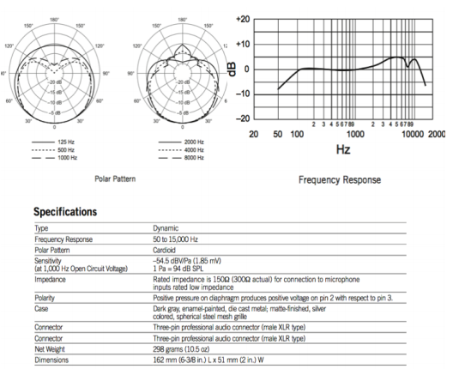 Figure C- 1 and Figure C- 2 provide an detailed specifications of the Shure SM58 and Sennheiser e604, respectively.

**Figure C- 1:** The necessary information regarding the Shure SM58 microphone model.

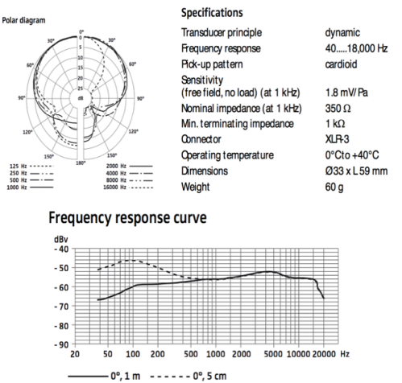

**Figure C- 2:** The necessary information regarding the Sennheiser e604 microphone model.

## Appendix D – Project Management: Project Timeline Breakdown

The status of the project currently stands at the end of its design process, satisfying the largest range of constraints and criteria. As the project progressed, new challenges arose while others were overcome. To better understand the details of the solution proposed and assist the team members in providing themselves enough time to innovate, create, and thoroughly go through various options of solutions, a GANTT chart was created and carefully implemented. In **Figure D-1**, an illustration of the used GANTT chart is presented, which was used by team members to allow them to follow a certain time frame per task/deliverable, and hence assure attaining the success desired. The GANTT chart was consistently updated to accommodate for any change of plans. Nonetheless, at the beginning of every new process, the chart was updated with deadlines for subtasks assigned. Hence, the utilization of such a powerful tool ensured the success of team members at meeting all the set deadlines.

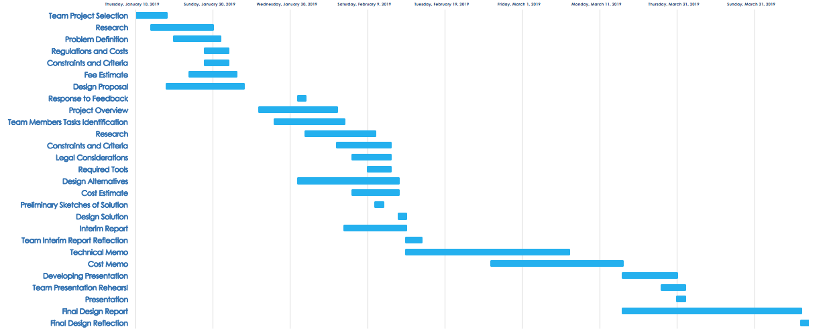

**Figure D- 1:** Gantt chart outline utilized by team members to complete deliverables by their deadlines.

To provide a brief overview of the fee estimate and working hour per team member, **Table D-2** was constructed to further provide a higher degree of accuracy of the costs required for the design’s labor portion of the project. It is worth noting, that this table was updated with most recent report according to the exact number of hours spend to reach this report. Additionally, the hourly wage used to calculate the labor costs is considered that of a newly graduate engineer like our team’s members, and with one to three years of experience in the field. Originally, the budget assigned for labor costs was approximately $25 539, meanwhile, the labor budget was higher by approximately $4 362. Upon the start of the design process, the realistic time frame for the number of hours required to complete the work was recorded for up to the Preliminary Report section. However, as the project progressed, accurate values were recorded. When presenting the loan figure that is required to execute the proposed design, approximately 20% increase in the loan required was accounted for, in order to take into consideration any unexpected extra costs or spending. Thus, the remaining budget available is believed to be sufficient to account for usage for research and development for the design solution.

**Table D- 1:** Summary chart outlining design labor fees of the project, and the working hours per individual.

|  |  |  |  |  |  |  |  |  |  |
| --- | --- | --- | --- | --- | --- | --- | --- | --- | --- |
| **Task** | **Individual** | | | | |  | | **Total** | |
|  | Ellag | Al-Fakhri | El-Bakary | Abdulmalek | Zaghloul |  | Working Hours | | Cost |
|  |  |  |  |  |  |  |  | |  |
| **1.0 Project Selection Research** |  |  |  |  |  |  |  | |  |
| 1.1 Idea Research and Selection | 4 | 4 | 4 | 4 | 4 |  | 20 | | $678.80 |
| **2.0 Design Proposal** |  |  |  |  |  |  |  | |  |
| 2.1 Problem Definition | 7 | 3 | 3 | 3 | 3 |  | 19 | | $644.86 |
| 2.2 Socioeconomic/Environmental Impacts | 5 | 5 | 6 | 2 | 1 |  | 19 | | $644.86 |
| 2.3 Regulations and Costs |  | 4 | 5 | 5 |  |  | 14 | | $475.16 |
| 2.3 Constraints and Criteria | 1 |  | 1 | 2 | 5 |  | 9 | | $305.46 |
| 2.4 Fee Estimate and Required Tools | 1 | 3 | 4 | 3 | 2 |  | 13 | | $441.22 |
| 2.5 Report Review | 1 | 1 | 1 | 1 | 1 |  | 5 | | $169.70 |
| **3.0 Preliminary Report** |  |  |  |  |  |  |  | |  |
| 3.1 Project Overview | 2 | 2 | 2 | 2 | 2 |  | 10 | | $339.40 |
| 3.2 Team Members Tasks Identification | 1 | 1 | 1 | 1 | 1 |  | 5 | | $169.70 |
| 3.3 Research | 6 | 6 | 4 | 5 | 3 |  | 24 | | $814.56 |
| 3.4 Constraints and Criteria | 2 | 1 | 1 | 1 | 5 |  | 10 | | $339.40 |
| 3.5 Legal Considerations/ Regulations |  | 5 | 2 | 3 |  |  | 10 | | $339.40 |
| 3.6 Preliminary Sketches of Solution | 2 | 1 |  | 2 |  |  | 5 | | $169.70 |
| 3.7 Updated Work Plan and Resources | 1 | 2 |  | 3 | 5 |  | 11 | | $373.34 |
| 3.8 Design Alternatives | 2 | 2 | 2 | 2 | 4 |  | 12 | | $407.28 |
| 3.9 Cost Estimate | 3 | 3 |  |  | 3 |  | 9 | | $305.46 |
| 3.10 Design Solution | 3 | 3 | 3 | 3 | 3 |  | 15 | | $509.10 |
| 3.11 Report Review | 1 | 1 | 1 | 1 | 1 |  | 5 | | $169.70 |
| **4.0 Technical Memorandum** |  |  |  |  |  |  |  | |  |
| 4.1 Detection System Research | 5 | 5 | 5 | 5 | 5 |  | 25 | | $848.50 |
| 4.2 Selection of Components | 6 | 5 | 6 | 7 | 7 |  | 31 | | $1,052.14 |
| 4.3 Calculations | 3 | 4 | 2 | 1 | 3 |  | 13 | | $441.22 |
| 4.4 Memorandum Review | 1 | 1 | 2 | 2 |  |  | 6 | | $203.64 |
| **5.0 Cost Memorandum** |  |  |  |  |  |  |  | |  |
| 5.1 System Cost Research | 4 | 5 | 6 | 4 | 7 |  | 26 | | $882.44 |
| 5.2 Labor, Capital, and Maintenance Cost | 3 | 2 | 1 | 4 | 5 |  | 15 | | $509.10 |
| 5.3 Legal Regulations and Calculations | 3 | 4 | 5 | 2 | 1 |  | 15 | | $509.10 |
| 5.4 Risk Management | 2 |  | 1 | 1 |  |  | 4 | | $135.76 |
| **6.0 Presentation** |  |  |  |  |  |  |  | |  |
| 6.1 Presentation Slide Preparation | 5 | 5 | 5 | 5 | 5 |  | 25 | | $848.50 |
| 6.2 Rehearsals | 3 | 3 | 3 | 3 | 3 |  | 15 | | $509.10 |
| 6.3 Actual Presentation | 2 | 2 | 2 | 2 | 2 |  | 10 | | $339.40 |
| **7.0 Final Design Report** | 35 | 35 | 35 | 35 | 35 |  | 175 | | $5,939.50 |
| 7.1 Project Overview | 2 | 2 | 2 | 2 | 2 |  | 10 | | $339.40 |
| 7.2 Team Members Tasks Identification | 1 | 1 | 1 | 1 | 1 |  | 5 | | $169.70 |
| 7.3 Research | 3 | 2 | 4 | 3 | 3 |  | 15 | | $509.10 |
| 7.4 Constraints and Criteria | 2 | 2 | 5 | 3 | 15 |  | 27 | | $916.38 |
| 7.5 Legal Considerations/ Regulations |  | 5 | 1 | 5 | 4 |  | 15 | | $509.10 |
| 7.6 Preliminary Sketches of Solution | 2 | 1 | 2 |  |  |  | 5 | | $169.70 |
| 7.7 Updated Work Plan and Resources | 1 | 1 | 1 | 1 | 1 |  | 5 | | $169.70 |
| 7.8 Design Alternatives | 2 | 8 | 11 |  | 7 |  | 28 | | $950.32 |
| 7.9 Cost Estimate | 6 | 5 | 3 | 11 |  |  | 25 | | $848.50 |
| 7.10 Technical Details | 13 | 7 | 2 |  |  |  | 22 | | $746.68 |
| 7.12 Sensitivity Analysis | 1 | 1 |  |  |  |  | 2 | | $67.88 |
| 7.13 Decision Matrices | 2 |  | 3 | 9 | 2 |  | 16 | | $543.04 |
| **8.0 Miscellaneous** |  |  |  |  |  |  |  | |  |
| 8.1 Group Meetings | 25 | 25 | 25 | 25 | 25 |  | 125 | | $4,242.50 |
| 8.2 GANTT Chart Construction | 3 |  | 3 |  |  |  | 6 | | $203.64 |
|  |  |  |  |  |  |  |  | |  |
|  |  |  |  |  |  |  |  | |  |
| **Total Hours/ Individual** | 177 | 178 | 176 | 174 | 176 |  | **881** | | **$29,901.14** |

The initial scope of the project was altered to fit the time constraint, knowledge, and resources possessed by the team members. Hear House still firmly grasps the importance of the implementation of a honk detection system, alongside its siren detection system. This will drastically improve our system’s power in the market,and will greatly benefit a larger demographic. The initial scope involved the examination of both detection systems. Nonetheless, as the project progressed, the team faced challenges regarding the amount of knowledge, period of time, and marketing research to understand the market’s response to the new system. In addition, the honk detection system requires a much more advanced and complex design that involves advanced detection methods that detect honks in the close vicinity of the car and eliminate all other noises/honks. This as a result was seen by the team as a rather challenging for the current time, yet a great target to be approached in the near future. Meanwhile, all team members are currently studying engineering, thus, did not gain all the crucial knowledge in order to successfully execute and implement such system. The team is still very committed to developing the honk detection system to accompany the siren detection system. However, it requires that essential courses like system controls, signals processing, and electrical devices be successfully completed by team members. Thus, the team decided to alter the scope to only focus on the siren detection system, and once the audience’s need for our system is assured, the team will continue to further expand and enhance the project. This will potentially attract a larger demographic as being a necessity in all cars.

## Appendix E – Cost Analysis

*ALL MONETARY VALUES ARE IN CANADIAN DOLLARS.*

***Capital Costs***

A. Research and Design:

* Certificates:

1) OHS Electrical – 105.00 CAD [23]

2) Instillation Safety – Canadian Electrical Code – 199.00 CAD [23]

3) PEO Certificate (Application) – 452.00 CAD [24]

4) ISO 9001:2015 Standards – 185.00 CAD [25]

5) IATF Code – 365.00 CAD [26]

6) CMDR and ISO 13485:2016 – 215.00 CAD [27]

Total1 = 1,521.00 CAD

B. Storage:

* Warehouse Structure:

1) Cost estimate of building a small-sized, pre-engineered, I-beam warehouse (15,000 square feet):

Cost per square foot (est.) = 10.51 CAD

Cost for a 15,000 square feet warehouse (est.) = $157,665.00 CAD [29] [30]

2) Cost estimate for a sprinkler fire-protection system (15,000 square feet):

Cost per square foot (est.) = 2.01 CAD

Cost for a 15,000 square feet warehouse (est.) = 30,150.00 CAD [31]

Total2 = 187,815.00 CAD

* Warehouse Breakdown:

The warehouse will include an office, a non-storage area (loading/unloading, hallways), and storage area (shelving racks).

1) Office Equipment (2,000 square feet):

Cost per square foot (est.) = 17.41 CAD

Cost for a 2,000 square feet office (est.) = 34,820.00 CAD [32]

2) Storage Area (10,000 square feet):

Shelving racks needed = 750 (10,000/13.33), where 13.33 is the area that one shelving rack covers in square feet.

Cost per one industrial shelving rack = 259.00 CAD

Cost for 750 racks = 750 rack x 259 CAD/rack = 194,250.00 CAD [33] [34]

Total3 = 229,070.00 CAD

∴Total Capital Cost=Total1+Total2+Total3

∴Total Capital Cost=1,521.00+187,815.00+229,070.00 = **$ 418,406.00** [28]

***Labour, Maintenance, and Unit Costs***

The three primary costs that will not be accounted for in the loan taken from the bank, are the labor, maintenance, and material costs. The maintenance costs are primarily concerned with the labour annual costs, as the maintenance is primarily concerned with the checking of defective parts. Since the lifetime of the system is durable, maintenance costs are expected for the replacements of small defective components, and thus no solid information could be provided. Additionally, labor costs required for maintenance of mobile application is accounted for. Therefore, maintenance costs are “invisibly” included in the labour costs which accounts for a full-time job of all the employees for a whole year, using standard working conditions of an 8-hour shift, and from Monday to Friday work. **Table E-1**, **Table E- 2**, and **Table E- 3** provide summaries of essential costs.

**Table E- 1:** Required software tools in order to successfully complete the design process.

|  |  |  |
| --- | --- | --- |
| **Tool Name** | **Description** | **Costs** |
| MATLAB or LABView | *This software will be used for signal processing and sound filtering.* | *Available at school for free* |
| AutoCAD Electrical | *This software will be used for circuit design.* | *Available at school for free* |
| SolidWorks | *This software will be used for 3D modeling.* | *Available at school for free* |
| Micro-computer & Design Environment | *This will be required for coding and running the system. (for simple design we will use Arduino Mega 2560[25]* | *CDN$ 63.99* |
| Machine Shop | *Access to a machine shop for modeling will be required for safety testing. (requires training)* | *Available at school for free* |

It is worth noting that the data presented in **Table E- 2**, present the maximum number of employers required given the current state of the company, and the scope of the design. It is believed that 2 workers for each category will provide more flexibility for the team to expand, rather than only working from our garage. It will also increase the degree of professionality, and space for new ideas to be contributed to the team.

**Table E- 2:** Summary chart utilized to estimate labor costs of the project, and the expected working hours per individual.

|  |  |  |  |  |
| --- | --- | --- | --- | --- |
| Job Title | Job Description | Number of Employees | Hourly Wage (CAD $) | Total Annual Cost (CAD $) |
| **Engineers:**  **Executive Team Members** | Research and develop the design solution, as well as run the company | 5 | $35.00 | $350 000.00 |
| **Assembly Technicians [7]** | Assemble the system in the car | 2 | $15.41 | $73 654.00 |
| **Quality Assurance Technicians [8]** | Ensure that the system is installed to its highest quality | 2 | $23.76 | $105 044.00 |
| **Mobile Application Developers [9]** | Develop the mobile application and maintain its safety | 2 | $20.39 | $125 300.00 |
|  |  |  |  |  |
| **TOTAL** |  | **11** | **$94.56** | **$653 998.00** |

**Table E- 3:** Summary chart utilized to estimate material costs of the project.

|  |  |  |  |  |  |
| --- | --- | --- | --- | --- | --- |
| Material | Number of Units | Price per Unit (CAD $) | | Total Price (CAD $) | |
| **Microphones[1]** | 4 units | | $111.93 | | $447.72 | |
| **Wires[2]** | 5.5 meters | | $2.00 | | $11.00 | |
| **Microcontroller[3]** | 1 units | | $134.00 | | $134.00 | |
| **DSP Processor [4]** | 1 units | | $398.00 | | $398.00 | |
| **ADC Chip** | 4 units | | $31.14 | | $124.56 | |
| **Electric Motor for Haptic System** | 1 unit | | $130.00 | | $130.00 | |
| **Voltage controller [5]** | 1 units | | $1.35 | | $1.35 | |
| **Heat shrinks [6]** | 2 meters | | $20.17 | | $40.34 | |
| **TOTAL** |  | |  | | **$1 286.97** | |

The newly graduate engineering wages accounted for were those for an hourly wages of a recently graduate engineer in Ontario, Canada. [16] The hourly wage is calculated to be $35.00, before tax. Deducting the taxes, the net hourly wage of each member is approximately $26.39. To account for such calculations, **Table E- 4** presents the necessary deductions calculated to obtain the suitable hourly wage per team member.

**Table E- 4:** Calculations utilized by team members to the appropriate hourly wage for the team’s engineer members, based on Ontario’s financial deductions.

|  |  |
| --- | --- |
| Salary | $35.00 |
| Federal tax deduction | -$4.59 |
| Provincial tax deduction | -$2.25 |
| CPP deductions | -$1.33 |
| EI deductions | -$0.44 |
|  |  |
| Total tax | -$8.61 |
| Net pay | **$26.39** |

Therefore, it could be concluded that the total capital costs including the design labor costs, total to approximately $ 448 307.14. These figures were calculated using worst case scenarios. Hence, a loan from an average Canadian Bank will provide this loan for a 7.25% annual interest rate with a repayment period of approximately 5 years. Therefore, it necessitates the payment of $ 9 959.68 monthly, accounting for the total interest costs. Therefore, the price of the units has to be able to produce a profit, and cover the materials and annual labor costs.

**Table E- 5:** Units sold per year, given a 10% annual increase in sales.

|  |  |
| --- | --- |
| Year | Units Sold |
| 0 | 100 |
| 1 | 110 |
| 2 | 121 |
| 3 | 133 |
| 4 | 146 |
| 5 | 161 |
| 6 | 177 |

In addition, it is reasonably assumed that Mercedes-Benz implements the system in 1% of its total car manufacturing output, and the team profits a 10% of each unit sold. The team is currently not concerned with the price markup the manufacturer will assign, but rather a 10% profit of each unit sold. Car manufacturers will most probably source their own material and labor stream. Thus, it is reasonable accounted that the car manufacturer will markup the car’s price by a minimum of $2 000.00. Therefore, the team wishes to profit $ 200.00 from every unit sold via the car manufacturer. Given that Mercedes-Benz sold approximately 2.3 million cars worldwide in 2017, the manufacturer can implement the system in approximately 23 000 cars per year. This accounts for a profit for *Hear House* of approximately $4 600 000 per year. Meanwhile, the unit price is set to an exact $1 500 when built independently by our team. Therefore, the payback period is as follows:

Assuming the team works independently, and successfully sells 100 cars per year:

Assuming the team works independently and with Mercedes-Benz:

## Appendix F – Sensitivity Analysis

Major assumptions taken into consideration:

* Loan annual interest rate of 7.25% and 5 years of repayment period
* A currency exchange value relative to the USD of 0.75 USD: 1 CAD
* Independent initial sales of 100 cars annually
* 15% profit from every unit implemented in Mercedes-Benz car models, taking into consideration that it implements it in 1% of its total car production

To understand the sensitivity of the design’s costs to every parameter assumed, a sensitivity analysis was completed using a 15% increase and decrease in every parameter.

## Appendix G – Survey Results and Significance to Design Solution

6

An anonymous survey was conducted between January 25th and January 27th of 2019, to help the authors/researchers of this report be well-rounded with all the influences hearing impairment imposes on a driver. Additionally, it provided a clear comparison basis that helped the authors further analyze the differences, challenges, and reaction to emergencies experienced between deaf and hearing drivers. The questions were unbiased, and no form of personal information was given during the survey. The survey was completed via the usage of *Survey Monkey* web base, and the responses are presented below. The results precisely proved our hypotheses of the methods by which hearing individuals would suspect about the importance of the auditory sensory, and their actions or reactions on the road while driving.

It became rather challenging at the beginning to design a solution that will become accepted by the public audience. Thus, the survey was primarily done to provide an insight into the audience’s perspective on the dangers of driving under certain parameters. Furthermore, the survey results provided the team with completely new and possible pathways to further develop the solution model in the future, once it is assured that the public embraces the design. This will be completed once marketing surveys and research are conducted within the next few months.

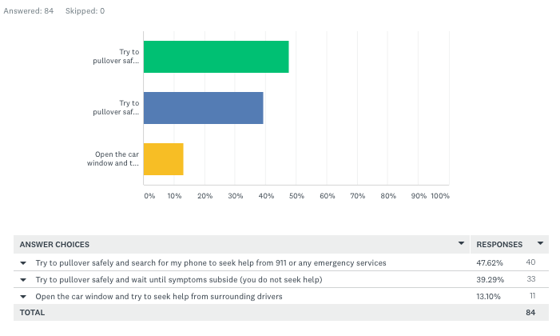**Q1: Scenario: Let's assume you are driving your car alone at a high speed, and suddenly you start to experience chest pain, dizziness, severe sweating and trembling, or any other dangerous medical condition that impairs your ability to drive. What is the first action that you will take in order to ensure your safety and others'?**

**Q2: IN YOUR OPINION, what do you think are the most challenging aspects of driving with a hearing impairment?**

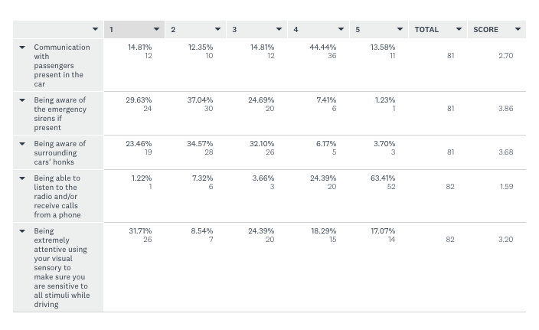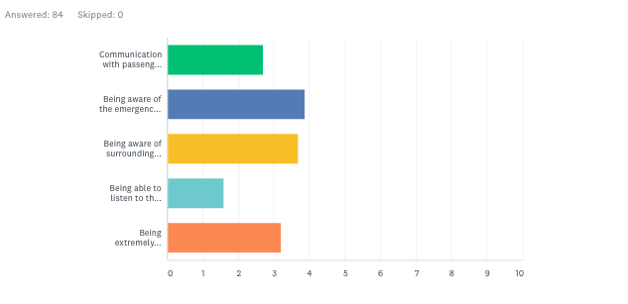

**Q3: What is the primary way you anticipate danger in the vicinity of your car while driving, assuming that you were distracted by something around you?**

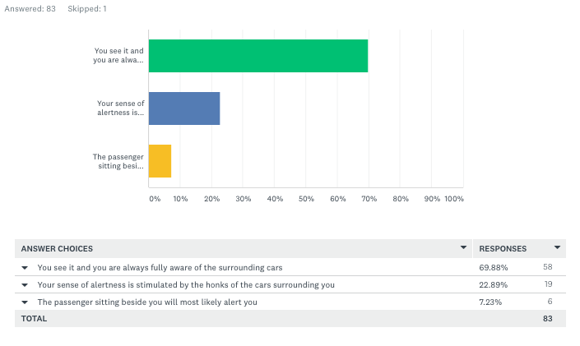

**Q4: IN YOUR OPINION, if you suffered from some degree of hearing impairment, what kind of distraction could you experience while driving?**

